BBF PI & Coordinator Package:
Coordination, Goals & Monitoring Gear

This package contains information regarding the “Coordination, Goals & Monitoring” Gear (CGMG) intended for the in-country BBF Team (PI, Coordinator and Research and/or Administrative Assistant) and BBF Committee Members. It is organized into the following sections:

- General description of the CGMG
- CGMG Benchmarks and examples- Table of all CGMG Benchmarks, scoring information and examples
- Identification of Available Data- This template is to help the coordinator(s) in identifying the available data prior to the 1st Meeting. The BBF committee will use this form during that 1st Meeting to determine a) what remaining information is necessary and b) the actual benchmark scores. Provide as much detail as possible when completing this form to facilitate an efficient data gathering process.
- Data Gathering Action Plan- During the 1st Meeting, Gear Teams will set out their strategy to gather the remaining information required to score each benchmark to ensure efficient and comprehensive data collection. This plan should specify who is responsible, the likely data needed, the data collection strategy for each member, and the anticipated deadlines for collection.
- Data Organization and Benchmark Scoring Pathways- The purpose of the Data Organization templates are to help organize all the information collected for each benchmark and are intended to capture the multidimensional nature of each benchmark. The project coordinator ensures all data is available for the Gear Teams and they complete these forms. Teams will then use them in conjunction with the Scoring Pathways and corresponding tables to reach the benchmark score.

Scoring Pathways are designed to assist with the actual scoring - follow the arrows in order to score the benchmark. The corresponding tables are for documenting discussion, any changes to the scores, the scoring justification and final score. Gear Teams will summarize and present the results to the BBF committee during the 2nd and 3rd Meetings in order to facilitate consensus on benchmark scores.
- CGMG1
- CGMG2
- CGMG3
- Recommended Actions - This table is for Gear Teams to outline/describe their proposed actions to address the gaps identified for the gear as a whole. These recommendations will form the basis of each Gear Team’s presentation during Meeting 4.

General description of the Coordination, Goals and Monitoring Gear (CGMG)

Key questions: Is there a government system in place that is responsible for coordinating the breastfeeding program at the national/state level? Is this system operational, decentralized and allow for effective decision making from the national to the local level?

Background

Scaling-up of breastfeeding programs and initiatives cannot be effective without having a strong, evidence-informed and decentralized coordinating system (i.e., coordinates effectively activities from the local to the national level). The Breastfeeding Gear Model (BFGM) posits that this coordinating system serves as the master gear, which sets and monitors overall goals and ensures all gears receive timely feedback, thereby enabling the breastfeeding program machine to function properly. Thus, goal setting and feedback are the key tools of the coordination gear.

Benchmarks

It is expected that a “National Breastfeeding Committee” or equivalent entity will be responsible for overall coordination and monitoring. There are three benchmarks that evaluate the existence and role of the National Breastfeeding Committee or equivalent entity. All benchmarks are referenced to “the past year” unless otherwise noted.

Domains

The benchmarks are designed to measure gear progress and they all have one or more Domain that assesses the different dimensions or elements within each benchmark:
Volume/Frequency: measures how much or how often
Quality: measures the quality of implementation
Effective (Operational): measures the adoption or level of incorporation
Existence: measure the actual presence of a program, legislation, policy, strategy, person, etc.
Coverage: measures the level of implementation (national, subnational, local)

Coordination, Goals and Monitoring Gear (CGMG) Benchmarks and examples

Specified Criteria for CGMG1:
a) Meets regularly b) Includes strong representation from civil organizations
c) Includes representation of sectors beyond health and nutrition
d) Set specific time bound breastfeeding objectives

Benchmark | Benchmark Scoring |  |  |  |  |  | Examples
 | 0  Not done |  | 1  Minimal progress | 2  Partial progress |  | 3  Major progress
CGMG1:  There is a National Breast-feeding Committee/ IYCF Committee. | There is no National Breastfeeding Committee/ IYCF Committee. | There is a National Breastfeeding Committee/ IYCF Committee but it does not meet any or only one of the specified criteria below. |  | There is a National Breastfeeding Committee/ IYCF Committee and it meets two to three of the specified criteria below. | There is a National Breastfeeding Committee/ IYCF Committee and it meets all of the specified criteria below. |  | Brazil has a National Coordination of Child Health and Breastfeeding which is composed by a core technical team responsible to coordinate nationally all issues related to the promotion, protection and support to breastfeeding, under the umbrella of Ministry of Health.  In 2006 a National Breastfeeding Committee (CNAM) was established to (1) support the process of articulation of the National Coordination of Child Health and Breastfeeding, (2) mobilize and sensitize sectors of government and civil society for the development of actions inherent to breastfeeding. This Committee is consulted by the Ministry of Health about breastfeeding promotion and protection issues.  The CNAM meets regularly once per month. This committee includes representation from government, universities, and civil organizations and can include specialists beyond health and nutrition whose presence is considered necessary to comply the provisions of the law (portaria 111, January 19, 2012).  Annually, Brazil’s National Coordination of Child Health and Breastfeeding develop a work plan setting specific time bound breastfeeding objectives which is discussed and validated with the National Breastfeeding Committee.  Score: Major Progress  Existence: Yes  Volume: Committee meets regularly  Quality: Committee includes strong representation from civil organizations and representation of sectors beyond health and nutrition and has set specific time bound breastfeeding objectives.  All criteria met.
CGMG2:  National Breast-feeding Committee/  IYCF committee work plan is reviewed and monitored regularly. | There is no National Breastfeeding Committee/  IYCF committee work plan. |  | There is a National Breastfeeding Committee/  IYCF committee work plan but it is not reviewed at least once every two years nor monitored once every year. | There is a National Breastfeeding Committee/  IYCF committee work plan and it is reviewed at least once every two years or monitored once every year. |  | There is a National Breastfeeding Committee/  IYCF committee work plan and it is reviewed at least once every two years and monitored once every year. | Annually, Brazil’s National Department of Child Health and Breastfeeding develop a work plan setting specific time bound breastfeeding objectives, which are then discussed and validated with the National Breastfeeding Committee at an intensive 2-day meeting.  At the end of each year, a management report from Ministry of Health is published describing the activities accomplished and the budget plan for the National Department of Child Health and Breastfeeding.  Score: Major Progress  Existence: There is a work plan in place.  Effective: The work plan is reviewed and monitored annually.
CGMG3: Data/  information related to breast-feeding program progress are used for decision-making and advocacy. | Data/  information related to breastfeeding program progress are not being used for decision-making and advocacy. |  | Data/  information related to breastfeeding program progress are used rarely (i.e. infrequently) for decision-making and advocacy. | Data/  information related to breastfeeding program progress are used sometimes (i.e. somewhat frequently) for decision-making and advocacy. |  | Data/  information related to breastfeeding program progress are used often (i.e. almost always/ always) for decision-making and advocacy. | The Mexico BBF Committee reviewed the National Breastfeeding Strategy 2014-2018 and the internal regulations of the Committee of Fair Start in Life and interviewed the CEO of the National Centre of Gender Equality and Reproductive Health. The evidence showed that recommendations issued by the Breastfeeding Committee are used to make decisions such as prioritizing actions, identifying needs and managing/allocating financial resources. However, the information is not made public and therefore cannot be used for advocacy.  The BBF Committee therefore recommended that the public be invited to the Permanent Interinstitutional Group on Support for the Breastfeeding (GIPALM) sessions and encourage unrepresented groups to collaborate and vote. Decisions and advances in GIPALM sessions should also be publicly communicated.  Score: Minimal Progress  Volume: Data and information related to breastfeeding program progress are used for decision-making but not for advocacy.

Identification of Available Data
Coordination, Goals & Monitoring Gear (CGMG)
This template is to help the coordinator in identifying the available data the national BBF committee will use to score the CGMG benchmarks. Provide as much detail as possible when completing this form to facilitate an efficient data gathering process.

Instructions: The data required for each benchmark is described below. Indicate in the Available Data column if that data is available: Yes (Y), No (N), Incomplete (I) or Don’t Know (DK).
Benchmark | Description of required data | Available Data  (Y/N/I/DK) | Reference/Data Sources  Describe where this data is located (e.g. website, report, person to interview, etc.)
CGMG1: There is a National Breastfeeding Committee/ IYCF Committee. | Domain: Existence  Is there a national breastfeeding or IYCF committee?  Domain: Quality  Who are the members? Is there representation from civil organizations and sectors beyond health and nutrition? How are objectives set?  Domain: Volume  How does the committee operate (i.e. how often does it meet)?
CGMG2: National Breastfeeding Committee/IYCF Committee work plan is reviewed and monitored regularly. | Domain: Existence Does the committee have a work plan?  Domain: Effective:  Who is responsible for reviewing and monitoring it? How frequently is this done? Where can information and progress of this work be found?  NOTE: If the country/state does not have a National Breastfeeding Committee/IYCF Committee, this benchmark must be scored as no progress.
CGMG3: Data related to breastfeeding program progress are used for decision-making and advocacy. | Domain: Volume  What evidence of data-driven decision making and advocacy is available? Is this evidence across the spectrum of BF activities or only in specific programs/ projects? How (if at all) is data used to provide feedback to policy makers about breastfeeding programs? What protocols are available for review?

Data Gathering Action Plan
Coordination, Goals & Monitoring Gear (CGMG)

This plan describes the strategy to gather information required to score each benchmark. The action plan must include a schedule of regular meetings or conference calls made in the intervening two months between Meeting 1 and Meeting 2. It is during this period that the Gear Teams must score their benchmarks.

Gear Team Members:

Instructions: In the table below, describe a) who will work on each benchmark, b) anticipated data to be used, and c) step-by-step data collecting strategy for each member. In the second table below, list the dates/times when members anticipate meeting each step for their benchmark(s).
Benchmark | Assigned Team member(s) | Potential Data Sources | Data Collection Strategy
CGMG1: There is a National Breastfeeding Committee/ IYCF Committee.
CGMG2: National Breastfeeding Committee/IYCF committee work plan is reviewed and monitored regularly.
CGMG3: Data/information related to breastfeeding program progress are used for decision-making and advocacy.

Scheduled Meetings: Describe the dates/times, methods (i.e., skype, in person) and content of anticipated meetings.
Date | Time | Method  (skype, in person, etc.) | Meeting agenda items | Anticipated attendees

Data Organization & Scoring Pathways
Coordination, Goals & Monitoring Gear (CGMG)

Data Organization: Please provide as much detail as possible to facilitate accurate scoring of each benchmark and development of recommendations. The relevant Domains are in bold.
CGMG1: There is a National Breastfeeding Committee/ IYCF Committee
Existence and Volume:  Describe the BF/IYCF committee and structure, including the frequency of meetings | Quality:  Name the members of the committee and their organizations, including those from civil organizations and/or sectors beyond health and nutrition | Quality:  Outline the objectives of the committee, including their time frames | References/ Data sources

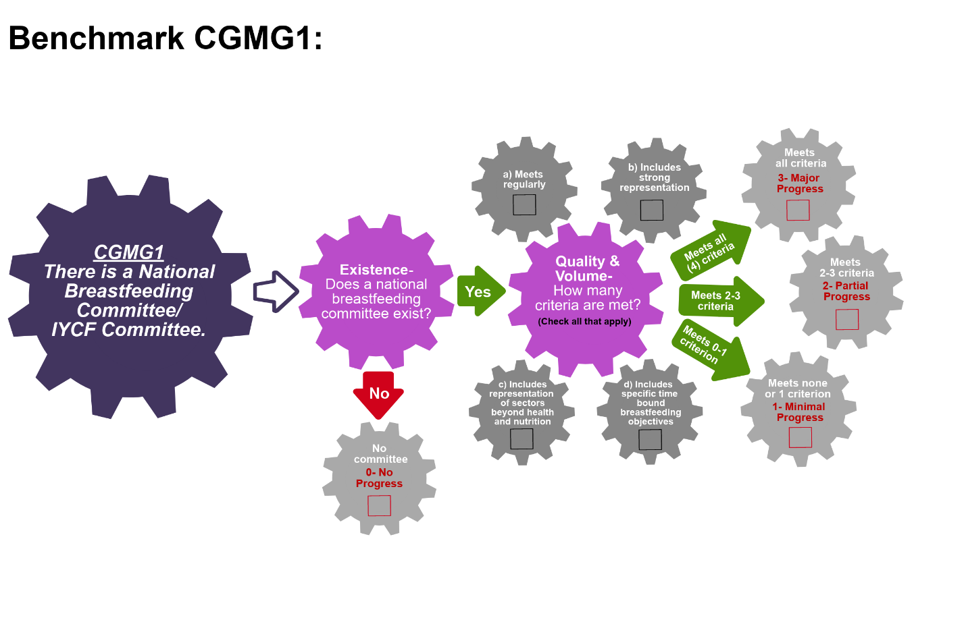
Scoring Pathway
☐

☐
☐
☐
☐
☐

☐

☐

**Insert the final score into the BBFI Calculator**

Instructions: Using the pathway, explain below the evolution of the final agreed score, i.e. rationale for any changes to the score, how the score was calculated (domains and criteria met), gaps identified and address any discrepancies of opinion within the Gear Team or Committee on the final score.
Date | Primary Score | Summary of Discussion | Scoring Justification | Final Score | Gaps identified
Between Meeting1 and 2

Date:
Meeting 2

Date:
Meeting 3

Date:
Data Organization: Please provide as much detail as possible to facilitate accurate scoring of each benchmark and development of recommendations. The relevant Domains are in bold
CGMG2: National Breastfeeding Committee/IYCF Committee work plan is reviewed and monitored regularly.
NOTE: If the country/state does not have a National Breastfeeding Committee/IYCF Committee, this benchmark must be scored as no progress.
Existence:  Describe the status of the work plan, i.e. under development, in progress or under review | Effective:  Explain who is responsible for reviewing and monitoring the plan | Effective:  Explain the frequency of review & monitoring activities | References/ Data sources

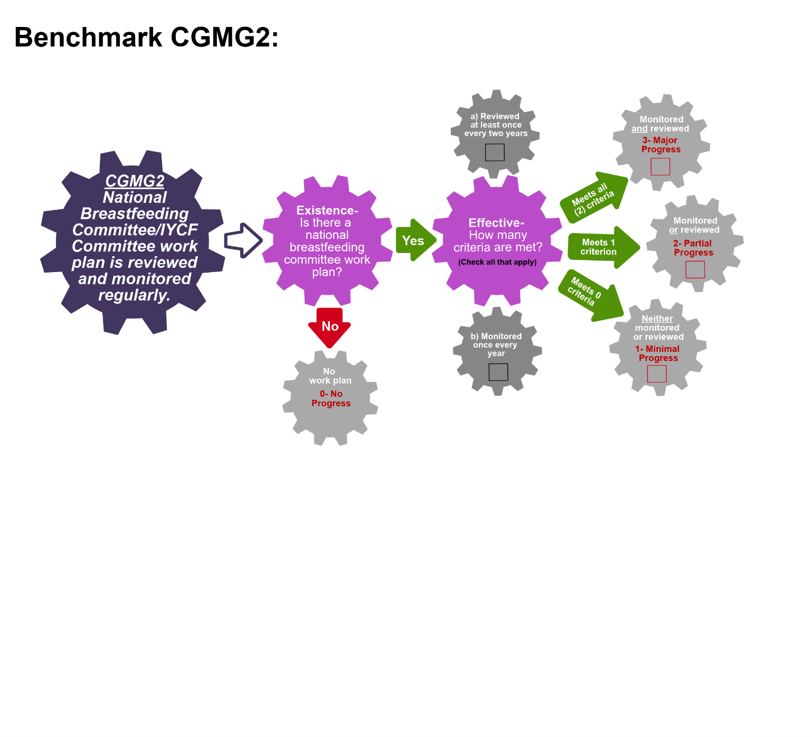
Scoring Pathway
☐

☐
☐
☐

☐
☐

**Insert the final score into the BBFI Calculator**

Instructions: Using the pathway, explain below the evolution of the final agreed score, i.e. rationale for any changes to the score, how the score was calculated (domains and criteria met), gaps identified and address any discrepancies of opinion within the Gear Team or Committee on the final score.
Date | Primary Score | Summary of Discussion | Scoring Justification | Final Score | Gaps identified
Between Meeting1 and 2

Date:
Meeting 2

Date:
Meeting 3

Date:

Data Organization: Please provide as much detail as possible to facilitate accurate scoring of each benchmark and development of recommendations. The relevant Domains are in bold.
CGMG3: Data related to breastfeeding program progress are used for decision-making and advocacy.
Volume:  Describe available evidence of data-driven decision making and advocacy, including frequency of occurrence | Volume:  List the protocols reviewed | Volume:  Describe how data is used to provide feedback to policy makes | References/Data Sources

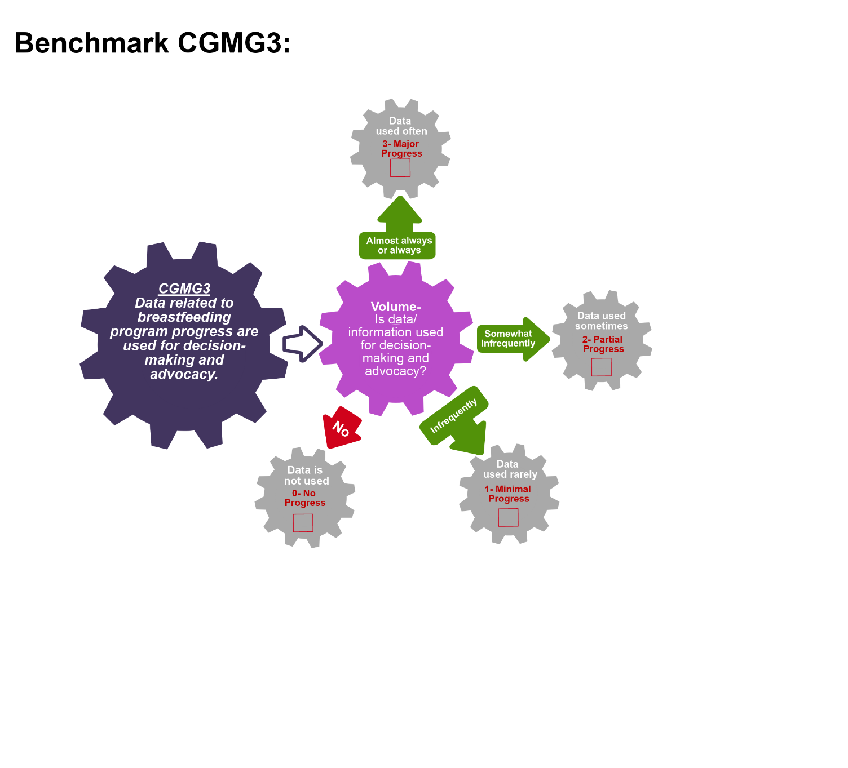
Scoring Pathway

☐

☐

☐

☐

**Insert the final score into the BBFI Calculator**
Instructions: Using the pathway, explain below the evolution of the final agreed score, i.e. rationale for any changes to the score, how the score was calculated (domains and criteria met), gaps identified and address any discrepancies of opinion within the Gear Team or Committee on the final score.
Date | Primary Score | Summary of Discussion | Scoring Justification | Final Score | Gaps identified
Between Meeting1 and 2

Date:
Meeting 2

Date:
Meeting 3

Date:
Recommended Actions
Coordination, Goals & Monitoring Gear (CGMG)

This template can be used to summarize possible recommendations for improvement where benchmarks have scored No Progress (0), Minimal Progress (1) or Partial Progress (2). This summary will form the basis of each Gear Team’s presentation during Meeting 4. Guidance will be made available on developing recommendations and prioritizing them.

Gaps Identified | Recommended Actions

Adapted from the WBTi (2014).

