BBF PI & Coordinator Package:
Research and Evaluation Gear

This package contains information regarding the Research and Evaluation (REG) intended for the in-country BBF Team (PI, Coordinator and Research and/or Administrative Assistant) and BBF Committee Members. It is organized into the following sections:

- General description of the Research and Evaluation Gear
- Research and Evaluation Gear Benchmarks and Examples - Table of all REG Benchmarks, scoring information and examples
- Identification of Available Data- This template is to help the coordinator(s) in identifying the available data prior to the 1st Meeting. The BBF committee will use this form during that 1st Meeting to determine a) what remaining information is necessary and b) the actual benchmark scores. Provide as much detail as possible when completing this form to facilitate an efficient data gathering process.
- Data Gathering Action Plan- During the 1st Meeting, Gear Teams will set out their strategy to gather the remaining information required to score each benchmark to ensure efficient and comprehensive data collection. This plan should specify who is responsible, the likely data needed, the data collection strategy for each member, and the anticipated deadlines for collection.
- Data Organization and Benchmark Scoring Pathways- The purpose of the Data Organization template is to help organize all the information collected for each benchmark and is intended to capture the multidimensional nature of each benchmark. The project coordinator collates data from the Gear Teams and completes this form. The Gear Teams will then use it in conjunction with the Scoring Pathway and corresponding table to reach the benchmark score. Gear Teams will summarize and present the results to the BBF committee during the 2nd and 3rd Meetings in order to facilitate consensus on benchmark scores.

These pathways are designed to assist with the actual scoring - follow the arrows in order to score the benchmark. The corresponding tables are for documenting discussion, any changes to the scores, the scoring justification and final score.
- REG1  - REG2  - REG3 | - REG4  - REG5  - REG6 | - REG7  - REG8 | - REG9  - REG10

- Recommended Actions - This table is for Gear Teams to outline/describe their proposed actions to address the gaps identified for the gear as a whole. These recommendations will form the basis of each Gear Team’s presentation during Meeting 4.
General description of the Research and Evaluation Gear (REG)

Key question: Is there a sound monitoring and evaluation system in place to guide and assess the quality and impacts of the national breastfeeding program?

Background

Scaling-up of breastfeeding programs and initiatives cannot be effective without decision makers having access to useful process and impact evaluations in a timely manner. For that to happen, research and evaluation tools need to be developed and implemented to ensure that the breastfeeding programs are being properly monitored for effectiveness and quality. Ineffective or poor quality programs should be easily identified and rectified if adequate monitoring and evaluation systems are in place. A sound multi-level monitoring and evaluation system is needed to share information from the local to the national level and to enable proper decision making, at each level, in a timely fashion. Thus, decision makers can directly invest in breastfeeding programs in efficient ways as well as invest in operational evaluation/research seeking to understand and continuously improve the quality of the national breastfeeding program.

Benchmarks

This gear evaluates the availability, integration, and monitoring of key breastfeeding practices. This gear also assesses the availability of monitoring systems to track implementation of activities essential to the scaling up of breastfeeding. Benchmarks 1-5 look at breastfeeding outcomes, and Benchmarks 6-10 assess the monitoring of process indicators. All benchmarks are referenced to “the past year” unless otherwise noted.

Domains

The benchmarks are designed to measure gear progress and they all have one or more Domain that assesses the different dimensions or elements within each benchmark:
Volume/Frequency: measures how much or how often
Quality: measures the quality of implementation
Effective (Operational): measures the adoption or level of incorporation
Existence: measure the actual presence of a program, legislation, policy, strategy, person, etc.
Coverage: measures the level of implementation (national, subnational, local)

Research and Evaluation Gear (REG) Benchmarks and examples

Benchmark | Benchmark Scoring |  |  |  | Examples
 | 0  Not done | 1  Minimal progress | 2  Partial progress | 3  Major progress
REG1: Indicators of key breastfeeding practices are routinely included in periodic national surveys. | Indicators of key breastfeeding practices are not routinely included in periodic national surveys. | Indicators of key breastfeeding practices are routinely included in periodic national surveys and this data are updated at least once every 10 years. | Indicators of key breastfeeding practices are routinely included in periodic national surveys and this data are renewed at least once every 5 years. | Indicators of key breastfeeding practices are routinely included in periodic national surveys and this data are renewed more than once every 5 years. | In Peru, the Continuous Demographic and Health Survey provides data annually on key breastfeeding indicators, including initial breastfeeding, exclusive BF < 6 months, and introduction of solid foods 6-9 months. The median BF duration indicator is reported every 2 years.  Score: Major Progress  Volume: Key breastfeeding practices are annually included in the national survey and data are renewed annually.
REG2: Key breastfeeding practices are monitored in routine health information systems. | Key breastfeeding practices are not monitored in routine health information systems. | Key breastfeeding practices are monitored in routine health information systems, but the systems are not electronic nor have key indicators been publicly reported. | Key breastfeeding practices are monitored in routine health information electronic systems, but the systems do not have full coverage (i.e. national, subnational, and local coverage) nor have key indicators been publicly reported. | Key breastfeeding practices are monitored in routine health information electronic systems, and the systems have full coverage (i.e. national, subnational, and local coverage) and key indicators have been public reported. | In Brazil, the National Information System for Primary Care electronically collects continuous data on the prevalence of EBF and BF for all health care users under 4 months of age. These data are available monthly to the public and have full coverage. This data has been used to plan and monitor breastfeeding interventions and drive decision making. For example, after analyzing these data, the Ministry of Health created a technical manual addressing breastfeeding and young feeding guidelines to qualify the community-based health professionals.  Score: Major Progress  Existence: Yes  Coverage: Full national coverage.  Quality: Key indicators are publicly reported.
REG3: Data on key breastfeeding practices are available at national and sub-national levels, including the local/ municipal level. | Data on key breastfeeding practices are not available at all levels. | Data on key breastfeeding practices are only available at the national level. | Data on key breastfeeding practices are available at the national level and subnational levels. | Data on key breastfeeding practices are available at the national, subnational and local/ municipal levels. | In Brazil, the on-line system SISVAN (Food and Nutrition Surveillance System) provide monthly data of BF (exclusive and not exclusive) for national and subnational level (including municipalities).  Score: Major Progress  Existence: Yes  Coverage: Data are available at all levels.
REG4: Data on key breastfeeding practices are representative of vulnerable groups. | Data on key breastfeeding practices are not representative of vulnerable groups. | Data on key breastfeeding practices are representative of vulnerable groups at the national level. | Data on key breastfeeding practices are representative of vulnerable groups at the national and subnational levels. | Data on key breastfeeding practices are representative of vulnerable groups at the national, subnational and local/municipal levels. | The definition of vulnerable groups can change for each country. In Brazil, these groups include the quilombo’s people descendents (quilombolas), riverside population (ribeirinhos), black and brown people. The SISVAN (Food and Nutrition Surveillance System) provides national, subnational and local breastfeeding data (exclusive and not exclusive) for each one of these vulnerable groups, monthly.  Score: Major Progress  Existence: Yes  Coverage: Data on vulnerable groups are available at all levels.
REG5: Indicators of key breastfeeding practices are placed in the public domain on a regular basis. | Themes of key breastfeeding practices (i.e., reports, breastfeeding databases, etc.) are not placed in the public domain. | Themes of key breastfeeding practices (i.e., reports, breastfeeding databases, etc.) are placed in the public domain less than once every two years. | Themes of key breastfeeding practices (i.e., reports, breastfeeding databases, etc.) are placed in the public domain every two years. | Themes of key breastfeeding practices (i.e., reports, breastfeeding databases, etc.) are placed in the public domain annually. | In USA, general data and standard reports of BF practices are public available on the CDC website. The data is made available annually though not every state provides the data annually or at all. The National Center for Health Statistics (NCHS) also developed the Research Data Centers (RDC) to allow researchers access to restricted data.  Score: Major Progress  Volume: Key breastfeeding practices are placed in the public domain annually.
REG6: A monitoring system is in place to track implementation of the Code. | No monitoring system in place to track implementation of the Code | There is a monitoring system in place to track implementation of the Code but it is not operational nor are process indicators publicly reported | There is a monitoring system in place to track implementation of the Code and it is operational or process indicators are publicly reported | There is a monitoring system in place to track implementation of the Code and it is operational and process indicators are publicly reported | In 1992, India adopted the Infant Milk Substitutes, Feeding Bottles and Infant Foods (Regulation of Production, Supply and Distribution) Act (IMS Act). The monitoring is conducted by the Ministry of Women and Child Development and the monitoring of the enforcement of the Act is undertaken by personnel and organizations formally notified by the government.  Following WHO criteria, the monitoring of the Code in India is transparent, independent, free of commercial influence, and empowered run the monitoring system to track implementation of the Code. It is partially operational as it has been used to track but there is a need for further improvement in enforcement. Although there is no specific budget for this activity, which negatively impacts the sustainability of the monitoring system, the Breastfeeding Promotion Network of India supports the government to implement the Act by developing monitoring tools and periodically reporting to the Ministry of Women and Child Development.  Score: Partial Progress  Existence: Yes  Effective: A monitoring system is in place to track implementation of the Code and process indicators are publicly reported. The need for further improvement in enforcement has been recognized.
REG7: A monitoring system is in place to track enforcement of maternity protection legislation. | There is no monitoring system in place to enforce maternity protection legislation. | There is a monitoring system in place to enforce maternity protection legislation but it is not operational nor are process indicators publicly reported. | There is a monitoring system in place to enforce maternity protection legislation and it is operational or process indicators are publicly reported. | There is a monitoring system in place to enforce maternity protection legislation and it is operational and process indicators are publicly reported. | In 2011, the Australian Government implemented the Paid Parental Leave (PPL) scheme to provide eligible working parents with up to 18 weeks of Government funded time off from work to care for a newborn or a recently adopted child. In addition to an extensive evaluation process of the scheme (including measuring breastfeeding rates before and after), the Department of Social Services (DSS) collects and publicly reports performance indicators measuring take up on a rolling three-year basis:  - Percentage and number of mothers for whom PPL has been paid as a proportion of all mothers in the same year  - Percentage and number of parents paid government-funded PPL by employers  - Percentage and number of families who have taken the full 18 weeks of PPL.  Score: Major Progress  Existence: Yes  Effective: DSS monitoring system is in place to enforce maternity protection legislation and process indicators are publicly reported.  In 2010, the Republic Azerbaijan ratified the ILO Maternity Protection Convention 2000 (No 183). It isn’t clear how well the law is being implemented due to an inadequate monitoring system. The State Labour Inspection Services is an organization within the Ministry of Labour and Social Protection of Population involved with the monitoring of maternity protection. Specifically, it “monitors the compliance with special employment conditions for women workers, as well as the application of health and safety provisions in hazardous industries, not only for women workers”. There is no current evidence that monitoring is actively occurring as “there have been no dedicated reports and compliance with the provisions prescribed by the Labour Code”. Without any available statistics on the use of maternity leave and take-up of provisions for pregnant/nursing women, it is challenging to know the usage, uptake, and compliance associated with the maternity protection legislation in Azerbaijan.  Score: No Progress  Existence: No  Effective: No evidence of a monitoring system in place to enforce maternity protection legislation.
REG8: A monitoring system is in place to track provision of lactation counseling/  management and support. | There is no monitoring system in place to track provision of lactation counseling/  management and support. | There is a monitoring system in place to track provision of lactation counseling/ management and support but it is not operational nor are process indicators publicly reported. | There is a monitoring system in place to track provision of lactation counseling/ management and it is operational or process indicators are publicly reported. | There is a monitoring system in place to track provision of lactation counseling/ management and support and it is operational and process indicators are publicly reported. | Alive & Thrive operate one-on-one and group counseling for pregnant women and mothers with children under 2 years with trained, certified counselors in Viet Nam. Each franchise completes a Monthly Report Form including information about the number of counseling contacts for exclusive breastfeeding (EBF) promotion, EBF support and management, and complementary feeding education, and management. The monitoring system provides an easy and streamlined program that allows for sharing data in a timely manner to facilitate evidence-based decision-making and improve program quality. The design of this system took into account the existing infrastructure of the health care system.  Score: Partial Progress  Existence: Yes  Effective: Monitoring system is operational but process indicators are not publicly reported.
REG9: A monitoring system is in place to track implementation of BFHI/ Ten Steps. | There is no monitoring system in place to track implementation of BFHI/Ten Steps. | There is a monitoring system in place to track implementation of BFHI/Ten Steps but it is not operational nor are process indicators publicly reported. | There is a monitoring system in place to track implementation of BFHI/Ten Steps and it is operational or process indicators are publicly reported. | There is a monitoring system in place to track implementation of BFHI/Ten Steps and it is operational and process indicators are publicly reported. | In Brazil, a monitoring system was developed and hospitals that are designated as Baby-Friendly must complete self-assessment forms every two years in order for the MOH monitor their compliance with the BFHI/Ten Steps. Every year the monitoring results are reported to the state level responsible for following up on the quality of the BFHI implementation.  Score: Partial Progress  Existence: Yes  Effective: Monitoring system is operational but process indicators are not publicly reported.
REG10: A monitoring system is in place to track behavior change communication (BCC) activities. | There is no monitoring system in place to track BCC activities. | There is a monitoring system in place to track behavior change communication activities but it is not operational nor are process indicators publicly reported. | There is a monitoring system in place to track behavior change communication activities and it is operational or process indicators are publicly reported. | There is a monitoring system in place to track behavior change communication activities and it is operational and process indicators are publicly reported. | Alive and Thrive (A&T) evaluates and monitors its breastfeeding media campaign in Viet Nam to understand the reach of the key messages and resulting changes in beliefs and behaviors. Two years into the campaign four of every five pregnant women or mothers with children under two years old, in the catchment areas, received personal IYCF counselling services and the rate of exclusive breastfeeding up to 6 months rose from 26% to 48%.  Data is submitted monthly and reports are produced on a rolling quarterly basis - produced monthly with performance indicators for the previous three months.  Score: Partial Progress  Existence: Yes  Effective: Monitoring system is operational but process indicators are not publicly reported.

Identification of Available Data
Research and Evaluation Gear
This template is to help the coordinator in identifying the available data the national BBF committee will use to score the PG benchmarks. Provide as much detail as possible when completing this form to facilitate an efficient data gathering process.
Instructions: For each benchmark, the data required is described. Indicate in the Available Data column if that data is available: Yes (Y), No (N), Incomplete (I) or Don’t Know (DK).
Benchmark | Description of required data | Available Data  (Y/N/I/DK) | Reference/Data Sources  Describe where this data is located (e.g. website, report, person to interview, etc.)
REG1: Indicators of key breastfeeding practices are routinely included in periodic national surveys. | Domain: Volume  Are BF practices included in any national surveys? How often are these surveys done? What questions are asked about BF?
REG2: Key breastfeeding practices are monitored in routine health information systems | Domain: Existence:  Are BF practices monitored through the health information systems?  Domain: Coverage:  What areas of the country are covered by the systems?  Domain: Quality:  What is the method and frequency of public reporting?
REG3: Data on key breastfeeding practices are available at national and sub-national levels, including the local/ municipal level. | Domain: Existence:  How and where is data on BF practices collected? What practices are included?  Domain: Coverage:  Is this data available at the national, sub-national and local level?
REG4: Data on key breastfeeding practices are representative of vulnerable groups. | Domain: Existence:  What data is available about different groups? Who is considered to be a "vulnerable" group?  Domain: Coverage:  What is the coverage of data on practices within these groups?
REG5: Indicators of key breastfeeding practices are placed in the public domain on a regular basis. | Domain: Volume:  Are key breastfeeding practices reported? How often are BF practices reported and where? Is there a breastfeeding database available for the public to access? Can these data be accessed easily?
REG6: A monitoring system is in place to track implementation of the Code. | Domain: Existence:  What is the monitoring system to track implementation of the Code?  Domain: Effective:  Is the system operational (i.e. can track and enforce violators of the code) and in use? What process indicators are available? When and how are these indicators publicly reported?
REG7: A monitoring system is in place to track enforcement of maternity protection legislation. | Domain: Existence:  What is the monitoring system to track maternity legislation enforcement?  Domain: Effective:  Is the system operational (i.e. can track and enforce violators of the law) and in use? What process indicators are available? When and how are these indicators publicly reported?
REG8: A monitoring system is in place to track provision of lactation counseling/  management and support | Domain: Existence:  What is the monitoring system to track lactation counseling?  Domain: Effective:  Is the system operational (i.e. can track counseling provision) and in use? What process indicators are available? When and how are these indicators publicly reported?
REG9: There is legislation supporting worksite accommodations for breastfeeding women. | Domain: Existence:  What is the monitoring system to track implementation of BFHI?  Domain: Effective:  What data is collected to track hospital training on BFHI/Ten Steps criteria and certification process? What data is collected about coverage and proportions of births in BFHI hospitals? What data is collected to track prevalence of implementation of each BFHI step in health facilities? What process indicators are available? When and how are these indicators publicly reported?
REG10: A monitoring system is in place to track behavior change communication (BCC) activities. | Domain: Existence:  What is the monitoring system to track BCC activities?  Domain: Effective:  Is the system operational (i.e. can track counseling provision) and in use? What process indicators are available? When and how are these indicators publicly reported?

Data Gathering Action Plan
Research and Evaluation Gear (REG)
This plan describes the strategy to gather information required to score each benchmark. The action plan must include a schedule of regular meetings or conference calls made in the intervening two months between Meeting 1 and Meeting 2. It is during this period that the Gear Teams must score their benchmarks.
Gear Team Members:
Benchmark | Assigned Team member(s) | Potential Data Sources | Data Collection Strategy
REG1: Indicators of key breastfeeding practices are routinely included in periodic national surveys.
REG2: Key breastfeeding practices are monitored in routine health information systems
REG3: Data on key breastfeeding practices are available at national and sub-national levels, including the local/ municipal level.

REG4: Data on key breastfeeding practices are representative of vulnerable groups.
REG5: Indicators of key breastfeeding practices are placed in the public domain on a regular basis.
REG6: A monitoring system is in place to track implementation of the Code.
REG7: A monitoring system is in place to track enforcement of maternity protection legislation.
REG8: A monitoring system is in place to track provision of lactation counseling/
management and support
REG9: A monitoring system is in place to track implementation of BFHI/ Ten Steps.
REG10: A monitoring system is in place to track behavior change communication (BCC) activities.

Scheduled Meetings: Describe the dates/times, methods (i.e., skype, in person) and content of anticipated meetings.
Date | Time | Method  (skype, in person, etc.) | Meeting agenda items | Anticipated attendees

Data Organization & Scoring Pathways
Research and Evaluation Gear
Data Organization: Please provide as much detail as possible to facilitate accurate scoring of each benchmark and development of recommendations. The relevant Domains are in bold.
REG1: Indicators of key breastfeeding practices are routinely included in periodic national surveys.
Volume:  Name of survey(s) | Volume:  Frequency of survey (e.g. annually, biannually etc) | Volume:  Key BF practices included | References/ Data sources

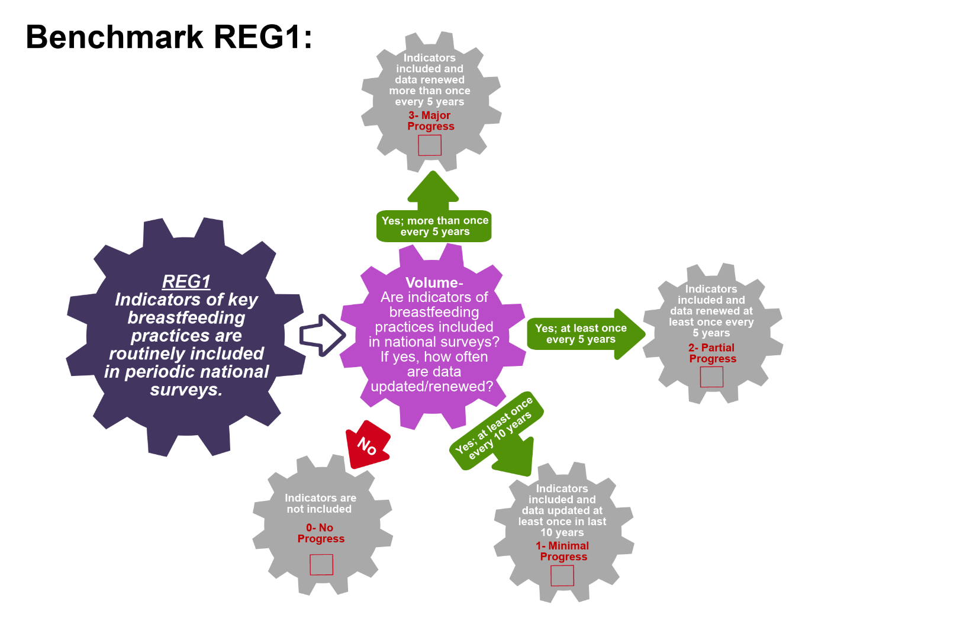
Scoring Pathway

☐
☐
☐

☐

**Insert the final score into the BBFI Calculator**
Instructions: Using the pathway, explain below the evolution of the final agreed score, i.e. rationale for any changes to the score, how the score was calculated (domains and criteria met), gaps identified and address any discrepancies of opinion within the Gear Team or Committee on the final score.
Date | Primary Score | Summary of Discussion | Scoring Justification | Final Score | Gaps identified
Between Meeting1 and 2

Date:
Meeting 2

Date:
Meeting 3

Date:
Data Organization: Please provide as much detail as possible to facilitate accurate scoring of each benchmark and development of recommendations. The relevant Domains are in bold.
REG2: Key breastfeeding practices are monitored in routine health information systems
Existence:  Names of health information systems | Existence:  BF practices monitored in system | Existence:  Is system electronic? | Coverage:  Area and level of coverage of system | Quality:  Explain the method and frequency of public reporting | References/ Data sources

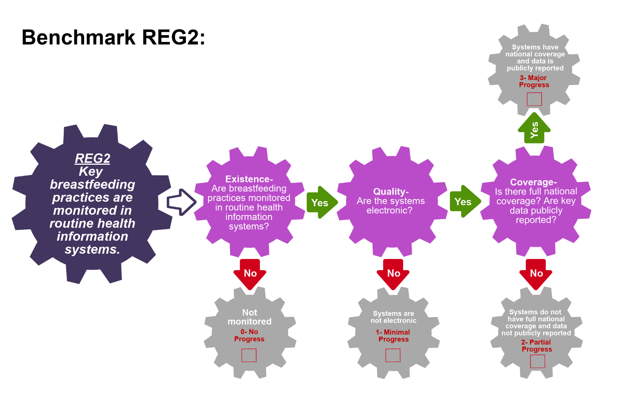
Scoring Pathway

☐

☐
☐
☐

**Insert the final score into the BBFI Calculator**
Instructions: Using the pathway, explain below the evolution of the final agreed score, i.e. rationale for any changes to the score, how the score was calculated (domains and criteria met), gaps identified and address any discrepancies of opinion within the Gear Team or Committee on the final score.
Date | Primary Score | Summary of Discussion | Scoring Justification | Final Score | Gaps identified
Between Meeting1 and 2

Date:
Meeting 2

Date:
Meeting 3

Date:

Data Organization: Please provide as much detail as possible to facilitate accurate scoring of each benchmark and development of recommendations. The relevant Domains are in bold.
REG3: Data on key breastfeeding practices are available at national and sub-national levels, including the local/ municipal level.
Existence:  Names of data collection systems | Existence:  BF practices included | Coverage:  Areas covered by data collection | References/ Data sources

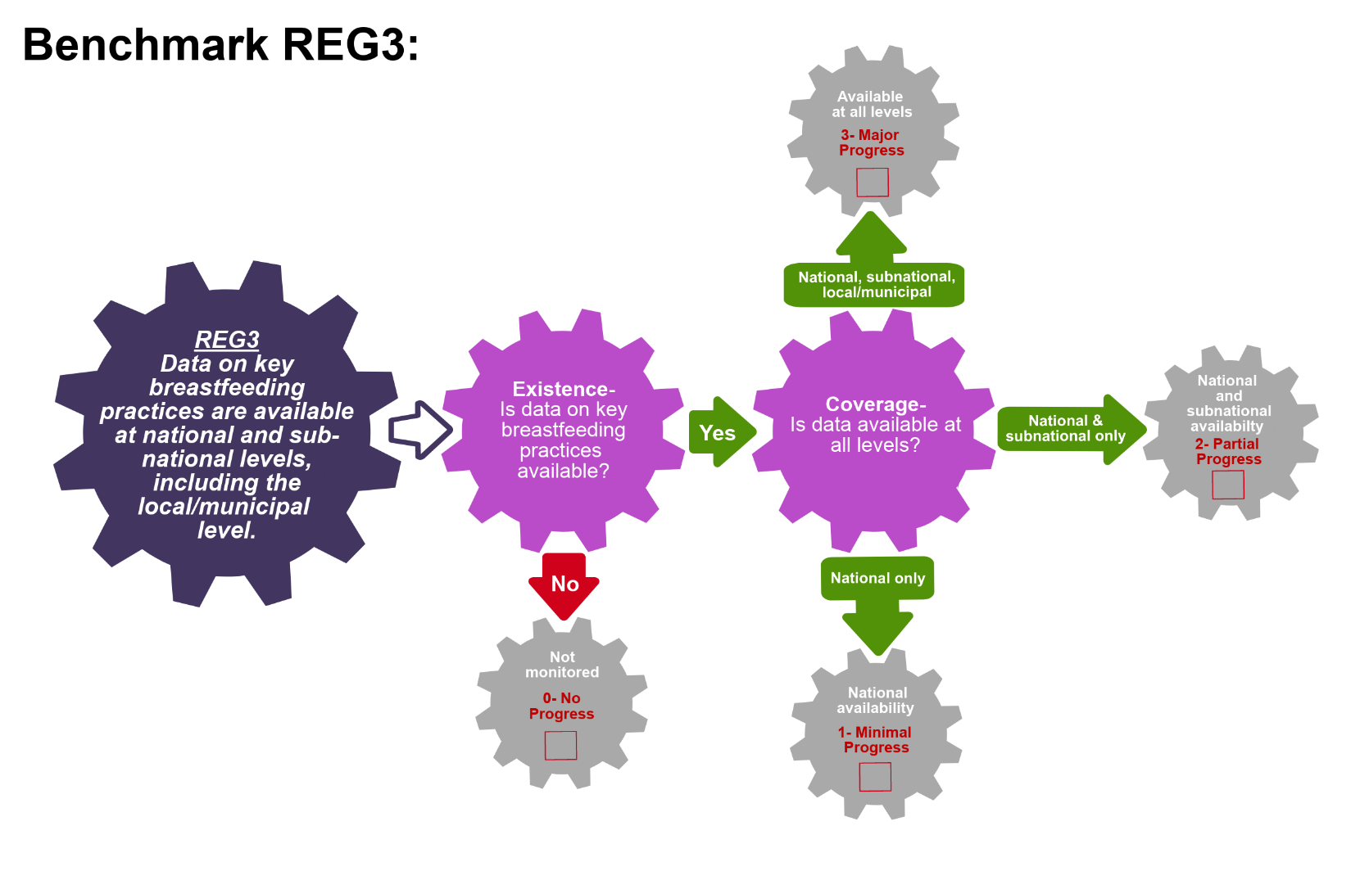
Scoring Pathway

☐
☐

☐

☐

**Insert the final score into the BBFI Calculator**
Instructions: Using the pathway, explain below the evolution of the final agreed score, i.e. rationale for any changes to the score, how the score was calculated (domains and criteria met), gaps identified and address any discrepancies of opinion within the Gear Team or Committee on the final score.
Date | Primary Score | Summary of Discussion | Scoring Justification | Final Score | Gaps identified
Between Meeting1 and 2

Date:
Meeting 2

Date:
Meeting 3

Date:
Data Organization: Please provide as much detail as possible to facilitate accurate scoring of each benchmark and development of recommendations. The relevant Domains are in bold.
REG4: Data on key breastfeeding practices are representative of vulnerable groups.
Existence:  Explain what data on key BF practices is available | Existence:  List the vulnerable groups represented in this data | Coverage:  Areas covered by this data | References/ Data sources

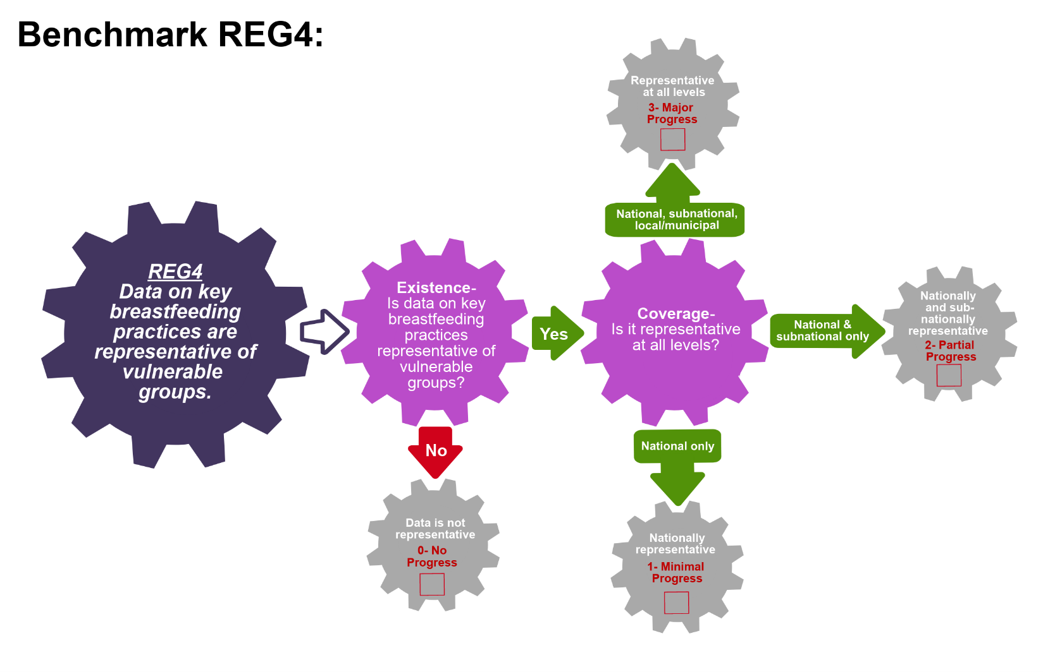
Scoring Pathway

☐

☐
☐

☐

**Insert the final score into the BBFI Calculator**
Instructions: Using the pathway, explain below the evolution of the final agreed score, i.e. rationale for any changes to the score, how the score was calculated (domains and criteria met), gaps identified and address any discrepancies of opinion within the Gear Team or Committee on the final score.
Date | Primary Score | Summary of Discussion | Scoring Justification | Final Score | Gaps identified
Between Meeting1 and 2

Date:
Meeting 2

Date:
Meeting 3

Date:

Data Organization: Please provide as much detail as possible to facilitate accurate scoring of each benchmark and development of recommendations. The relevant Domains are in bold.
REG5: Indicators of key breastfeeding practices are placed in the public domain on a regular basis.
Volume:  Describe how data on BF practices are made public | Volume:  Frequency of reporting/updating of databases (i.e. annually, bi-annually etc ) | References/ Data sources

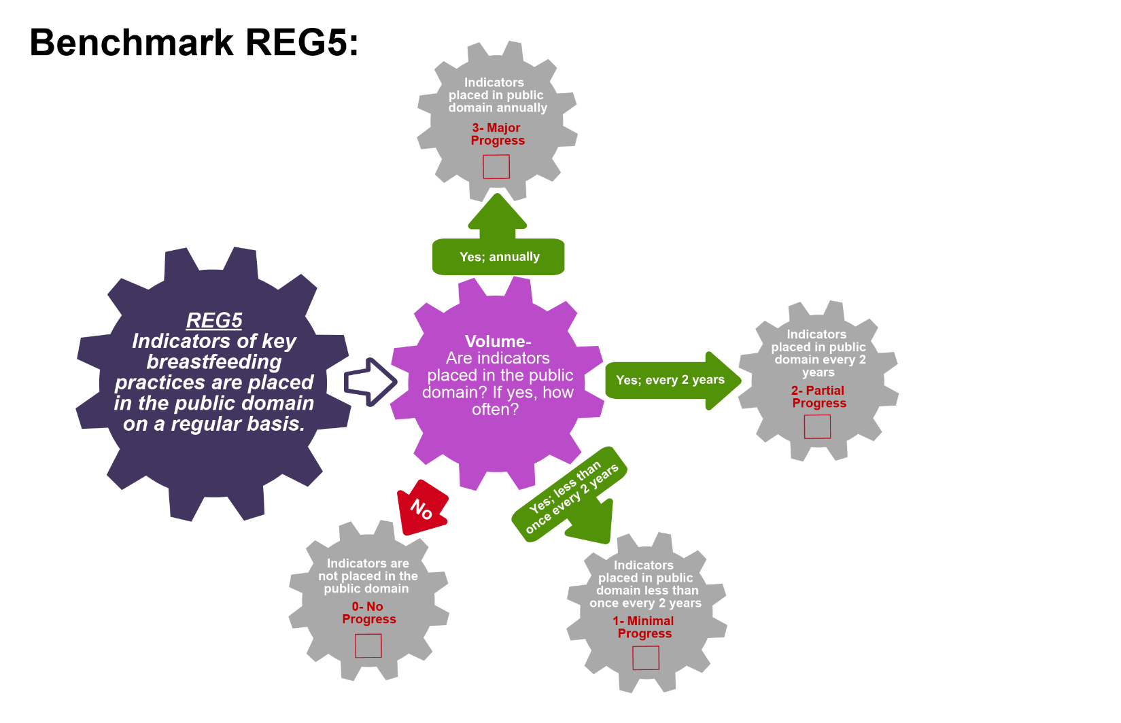
Scoring Pathway

☐
☐
☐
☐

**Insert the final score into the BBFI Calculator**
Instructions: Using the pathway, explain below the evolution of the final agreed score, i.e. rationale for any changes to the score, how the score was calculated (domains and criteria met), gaps identified and address any discrepancies of opinion within the Gear Team or Committee on the final score.
Date | Primary Score | Summary of Discussion | Scoring Justification | Final Score | Gaps identified
Between Meeting1 and 2

Date:
Meeting 2

Date:
Meeting 3

Date:

Data Organization: Please provide as much detail as possible to facilitate accurate scoring of each benchmark and development of recommendations. The relevant Domains are in bold.
REG6: A monitoring system is in place to track implementation of the Code.
Existence:  Describe the monitoring system | Effective:  Explain how the system is used and by whom | Effective:  List the process indicators used to track Code implementation | Effective:  Describe how and when the indicators are available and publicly reported | References/ Data sources

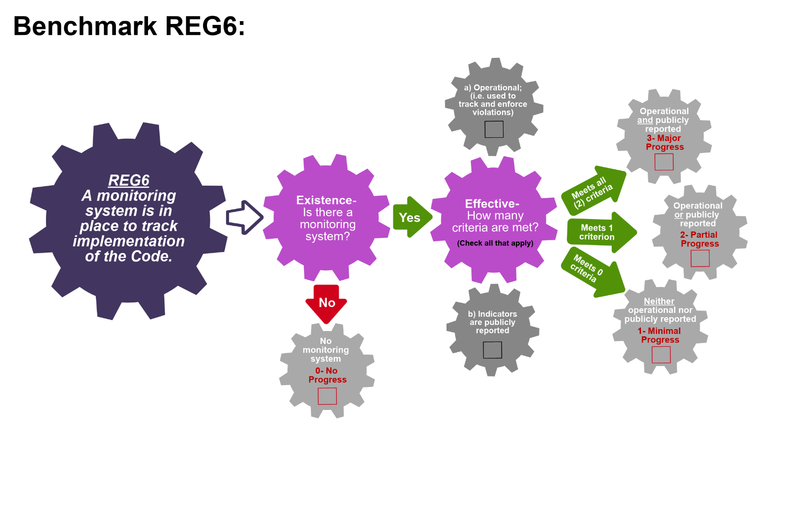
Scoring Pathway

☐
☐
☐
☐
☐
☐

**Insert the final score into the BBFI Calculator**
Instructions: Using the pathway, explain below the evolution of the final agreed score, i.e. rationale for any changes to the score, how the score was calculated (domains and criteria met), gaps identified and address any discrepancies of opinion within the Gear Team or Committee on the final score.
Date | Primary Score | Summary of Discussion | Scoring Justification | Final Score | Gaps identified
Between Meeting1 and 2

Date:
Meeting 2

Date:
Meeting 3

Date:

Data Organization: Please provide as much detail as possible to facilitate accurate scoring of each benchmark and development of recommendations. The relevant Domains are in bold.
REG7: A monitoring system is in place to track enforcement of maternity protection legislation.
Existence:  Describe the monitoring system | Effective:  Explain how the system is used and by whom | Effective:  List the process indicators used to track maternity legislation implementation | Effective:  Describe how and when the indicators are available and publicly reported | References/ Data sources

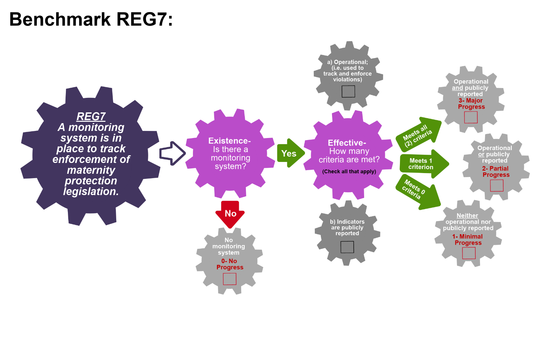
Scoring Pathway
☐
☐
☐
☐
☐

☐

**Insert the final score into the BBFI Calculator**
Instructions: Using the pathway, explain below the evolution of the final agreed score, i.e. rationale for any changes to the score, how the score was calculated (domains and criteria met), gaps identified and address any discrepancies of opinion within the Gear Team or Committee on the final score.
Date | Primary Score | Summary of Discussion | Scoring Justification | Final Score | Gaps identified
Between Meeting1 and 2

Date:
Meeting 2

Date:
Meeting 3

Date:

Data Organization: Please provide as much detail as possible to facilitate accurate scoring of each benchmark and development of recommendations. The relevant Domains are in bold.
REG8: A monitoring system is in place to track provision of lactation counseling/management and support
Existence:  Describe the monitoring system | Effective:  Explain how the system is used and by whom | Effective:  List the process indicators used to track lactation counseling | Effective:  Describe how and when the indicators are available and publicly reported | References/ Data sources

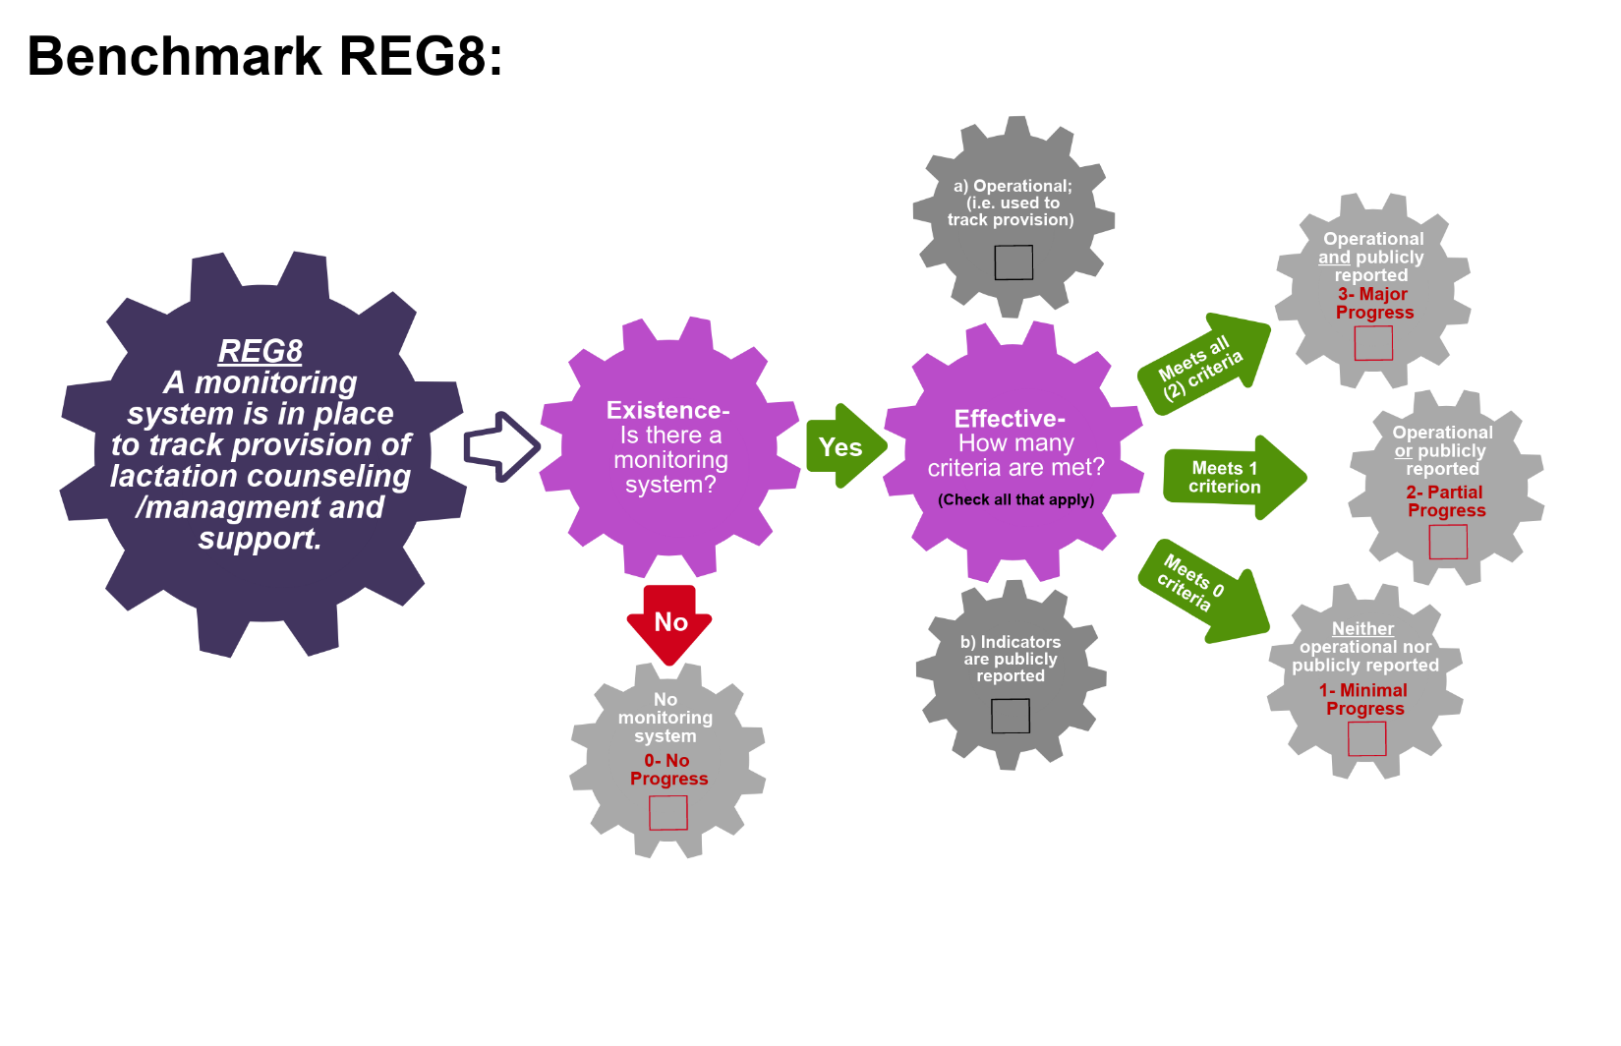
Scoring Pathway
☐
☐
☐
☐
☐
☐

**Insert the final score into the BBFI Calculator**
Instructions: Using the pathway, explain below the evolution of the final agreed score, i.e. rationale for any changes to the score, how the score was calculated (domains and criteria met), gaps identified and address any discrepancies of opinion within the Gear Team or Committee on the final score.
Date | Primary Score | Summary of Discussion | Scoring Justification | Final Score | Gaps identified
Between Meeting1 and 2

Date:
Meeting 2

Date:
Meeting 3

Date:

Data Organization: Please provide as much detail as possible to facilitate accurate scoring of each benchmark and development of recommendations. The relevant Domains are in bold.
REG9: A monitoring system is in place to track implementation of BFHI/ Ten Steps.
Existence:  Describe the monitoring system and how it is used to track compliance with BFHI/Ten Steps | Effective:  Describe the process indicators that measure implementation activities of the BFHI/Ten Steps | Effective:  Describe how and when the indicators are available and publicly reported | References/ Data sources

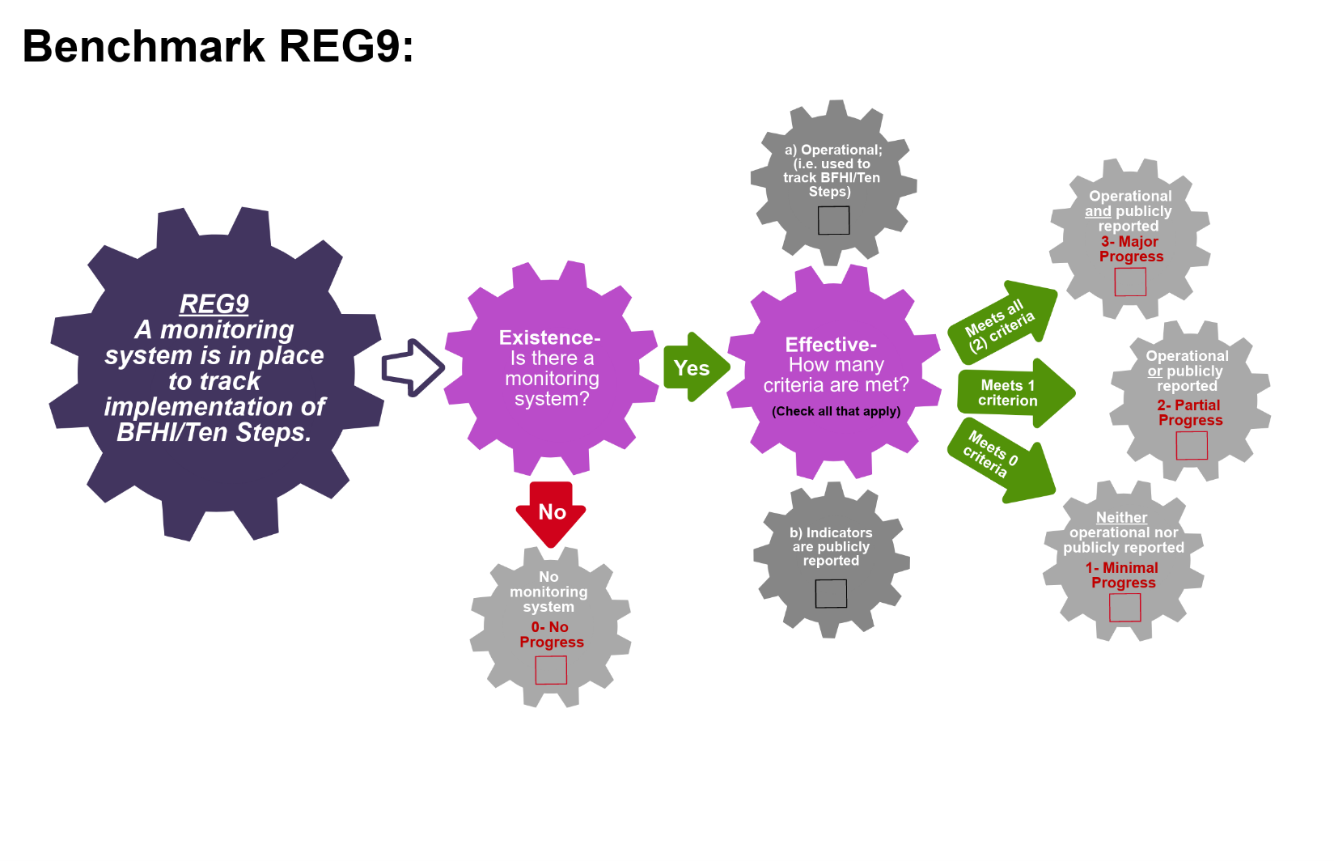
Scoring Pathway
☐

☐
☐
☐
☐

☐

**Insert the final score into the BBFI Calculator**
Instructions: Using the pathway, explain below the evolution of the final agreed score, i.e. rationale for any changes to the score, how the score was calculated (domains and criteria met), gaps identified and address any discrepancies of opinion within the Gear Team or Committee on the final score.
Date | Primary Score | Summary of Discussion | Scoring Justification | Final Score | Gaps identified
Between Meeting1 and 2

Date:
Meeting 2

Date:
Meeting 3

Date:

Data Organization: Please provide as much detail as possible to facilitate accurate scoring of each benchmark and development of recommendations. The relevant Domains are in bold.
REG10: A monitoring system is in place to track behavior change communication (BCC) activities.
Existence:  Describe the monitoring system and how it is used to track counseling provision | Effective:  Describe the process indicators that measure BCC activities | Effective:  Describe how and when the indicators are available and publicly reported | References/ Data sources

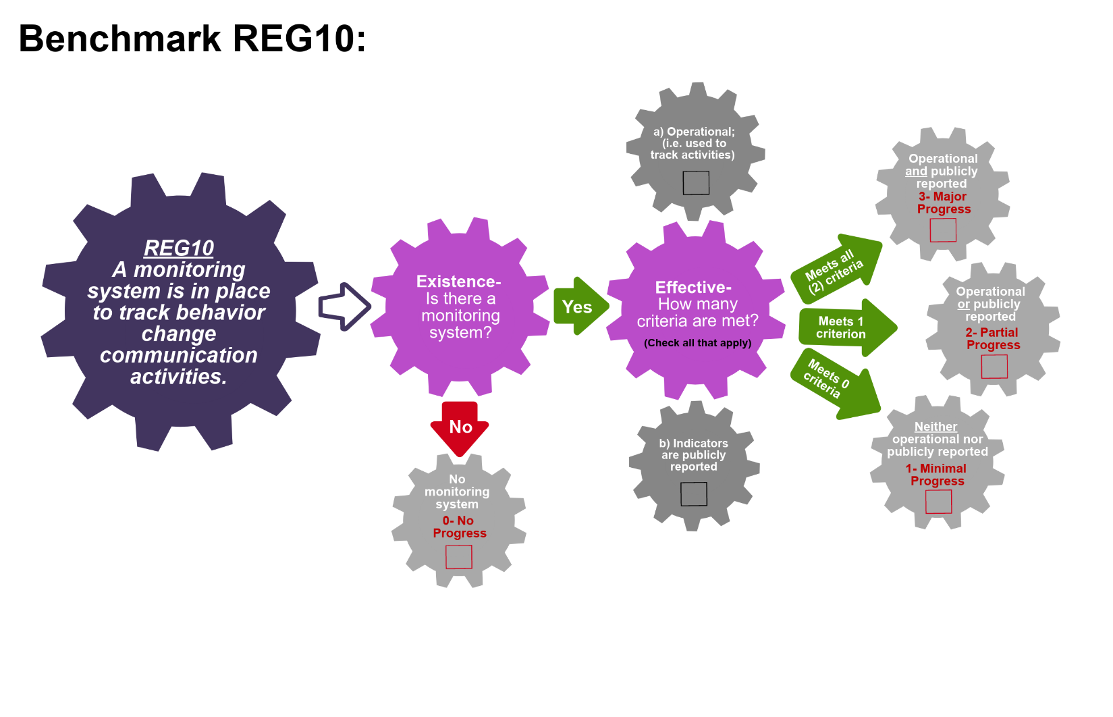
Scoring Pathway
☐
☐
☐
☐
☐

☐

**Insert the final score into the BBFI Calculator**
Instructions: Using the pathway, explain below the evolution of the final agreed score, i.e. rationale for any changes to the score, how the score was calculated (domains and criteria met), gaps identified and address any discrepancies of opinion within the Gear Team or Committee on the final score.
Date | Primary Score | Summary of Discussion | Scoring Justification | Final Score | Gaps identified
Between Meeting1 and 2

Date:
Meeting 2

Date:
Meeting 3

Date:

Recommended Actions
Research and Evaluation Gear (REG)

This template can be used to summarize possible recommendations for improvement where benchmarks have scored No Progress (0), Minimal Progress (1) or Partial Progress (2). This summary will form the basis of each Gear Team’s presentation during Meeting 4. Guidance will be made available on developing recommendations and prioritizing them.
Gaps Identified | Recommended Actions

