BBF PI & Coordinator Package:
Training and Program Delivery Gear

This package contains information regarding the Training and Program Delivery Gear (TPDG) intended for the in-country BBF Team, comprising the PI, Coordinator and Research and/or Administrative Assistant and is organized into the following sections:

- General description of the Training and Program Delivery Gear
- Training and Program Delivery Gear Benchmarks and Examples - Table of all TPDG Benchmarks, scoring information and examples
- Identification of Available Data- This template is to help the coordinator(s) in identifying the available data prior to the 1st Meeting. The BBF committee will use this form during that 1st Meeting to determine a) what remaining information is necessary and b) the actual benchmark scores. Provide as much detail as possible when completing this form to facilitate an efficient data gathering process.
- Data Gathering Action Plan- During the 1st Meeting, Gear Teams will set out their strategy to gather the remaining information required to score each benchmark to ensure efficient and comprehensive data collection. This plan should specify who is responsible, the likely data needed, the data collection strategy for each member, and the anticipated deadlines for collection.
- Data Organization and Benchmark Scoring Pathways- The purpose of the Data Organization templates are to help organize all the information collected for each benchmark and are intended to capture the multidimensional nature of each benchmark. The project coordinator ensures all data is available for the Gear Teams and they complete these forms. Teams will then use them in conjunction with the Scoring Pathways and corresponding tables to reach the benchmark score.

Scoring Pathways are designed to assist with the actual scoring - follow the arrows in order to score the benchmark. The corresponding tables are for documenting discussion, any changes to the scores, the scoring justification and final score. Gear Teams will summarize and present the results to the BBF committee during the 2nd and 3rd Meetings in order to facilitate consensus on benchmark scores.

- TPDG1  - TPDG2  - TPDG3  - TPDG4 | - TPDG5  - TPDG6  - TPDG7  - TPDG8 | - TPDG9  - TPDG10  - TPDG11  - TPDG12 | - TPDG13  - TPDG14  - TPDG15  - TPDG16  - TPDG17

- Recommended Actions - This table is for Gear Teams to outline/describe their proposed actions to address the gaps identified for the gear as a whole. These recommendations will form the basis of each Gear Team’s presentation during Meeting 4.

General description of the Training and Program Delivery Gear (TPDG)

Key questions: Is skills training provided to students (pre-service training) and health care providers (post-service training) in order to support optimal breastfeeding? Are there facility and community-based programs established to provide breastfeeding support?

Background

Scaling-up of breastfeeding programs and initiatives cannot be effective without wide reaching, standardized training programs that educate health care students, providers, and breastfeeding support staff on breastfeeding best practices. Successful breastfeeding programs require that all care providers must be trained, including health professionals and others, working in facility-based or community-based programs serving women and children. Curricula taught to those who interact with mothers during pregnancy and the postpartum period need to include education on the basic attitudes, knowledge and skills necessary to integrate breastfeeding counseling and lactation management into their care.

Having a comprehensive and wide reaching training program is effective if it is combined with extensive program delivery. Program delivery must be present at all levels of health care, including facility-based programs (such as the Baby-Friendly Hospital Initiative (BFHI)) and community-based programs (including mother-to-mother support activities) for large scale breastfeeding efforts to occur.

Benchmarks

The benchmarks for this gear evaluate the quality and coverage of pre-service and in-service training and facility/community-based program delivery. The areas of assessment include improving workforce capacity through training at the pre-service level for health care providers and at the in-service level for facility and community-based health care providers and community health workers. The gear also looks at the coverage and quality of breastfeeding program delivery at facility and community levels. All benchmarks are referenced to “the past year” unless otherwise noted.

Domains

The benchmarks are designed to measure gear progress and they all have one or more Domain that assesses the different dimensions or elements within each benchmark:
Volume/Frequency: measures how much or how often
Quality: measures the quality of implementation
Effective (Operational): measures the adoption or level of incorporation
Existence: measure the actual presence of a program, legislation, policy, strategy, person, etc.
Coverage: measures the level of implementation (national, subnational, local)

Training and Program Delivery Gear (TPDG) Benchmarks and examples

Benchmark | Benchmark Scoring |  |  |  |  |  | Examples
 | 0  Not done |  | 1  Minimal progress |  | 2  Partial progress | 3  Major progress
TPDG1:  A review of health provider schools and pre-service education programs for health care professionals that will care for mothers, infants and young children indicates that there are curricula that cover essential topics of breastfeeding. | Breastfeeding curricula do not exist in pre-service programs for health care professionals that will care for mothers, infants and young children. |  | Breastfeeding curricula exist in these pre-service programs but the curricula do not cover all essential breastfeeding topics and they are not integrated within all pre-service programs. |  | Breastfeeding curricula exist in these pre-service programs and the curricula cover all essential breastfeeding topics or they are integrated within all pre-service programs. | Breastfeeding curricula exist in these pre-service programs and the curricula cover all essential breastfeeding topics and they are integrated within all pre-service programs. | Little data exists about the presence and quality of breastfeeding within medical pre-service education curriculums in the US. A seminal study in the US in 1995 on residency training for physicians caring for mothers, infants, and young children found that residents within all areas didn’t demonstrate effective breastfeeding management and care. Since then, the studies that have emerged in this area have shown that pre-service breastfeeding training for residents hasn’t significantly improved. The American Academy of Pediatrics (AAP) have developed a Breastfeeding Residency Curriculum and set of curriculum tools for residents (pre-service training) but these have not been adopted by all the institutions providing pre service training for health professionals.  Score: Minimal Progress  Existence: Yes  Coverage: Breastfeeding curriculum is not integrated within all pre-service programs  Quality: Curriculum does not cover all the essential topics in Annex 4.
TPDG2:  Facility-based health care professionals who care for mothers, infants and young children are trained on the essential breastfeeding topics as well as their responsibilities under the Code implementation. | Breastfeeding training does not exist in in-service programs for facility-based health care professionals who care for mothers, infants and young children. |  | Breastfeeding training exists in in-service programs for facility-based health care professionals who care for mothers, infants and young children but the curricula do not cover all essential breastfeeding topics and breastfeeding curricula are not integrated within all in-service facility-based programs. |  | Breastfeeding training exists in in -service programs for facility-based health care professionals who care for mothers, infants and young children and the curricula cover all essential breastfeeding topics or breastfeeding curricula are integrated within all in-service facility-based programs. | Breastfeeding training exists in in-service programs for facility-based health care professionals who care for mothers, infants and young children and the curricula cover all essential breastfeeding topics and breastfeeding curricula are integrated within all in-service facility-based programs. | The Ministry of Health of Viet Nam developed their IYCF training program based on WHO, UNICEF and Alive & Thrive training material. The 40 sessions, including 25 theory sessions and 15 practical are focused on breastfeeding and complementary feeding. All the essential topics in Annex 4 are included in this training manual, with the exception of contraception. (Listed as a resource on the website)  Score: Partial Progress  Existence: Yes  Quality: All topics in Annex 4 (with the one exception of contraception) are included.  Effective: Not enough information to assess the level of integration of breastfeeding training into the curricula of all facility-based in-service programs.
TPDG3:  Facility-based health care professionals who care for mothers, infants and young children receive hands-on training in essential topics for counseling and support skills for breastfeeding | Hands-on breastfeeding training does not exist in in-service programs for facility-based health care professionals who care for mothers, infants and young children. |  | Hands-on breastfeeding training exists in these in-service programs but the curricula do not cover all essential breastfeeding counseling and support skills topics and breastfeeding curricula are not integrated within all in-service facility-based programs. |  | Hands-on breastfeeding training exists in these in-service programs and the curricula cover all essential breastfeeding counseling and support skills topics or breastfeeding curricula are integrated within all facility-based in-service programs. | Hands-on breastfeeding training exists in these in-service programs and the curricula cover all essential breastfeeding counseling and support skills topics and breastfeeding curricula are integrated within all facility-based in-service programs. | The Ministry of Health of Viet Nam developed their IYCF training program based on WHO, UNICEF and Alive & Thrive training material. The 40 sessions, including 25 theory sessions and 15 practical sessions are focused on breastfeeding and complementary feeding. All the essential topics in Annex 5 are included in this training manual, with the exception of contraception. (Listed as a resource on the website)  Score: Partial Progress  Existence: Yes  Quality: All topics in Annex 5 (with the one exception of contraception) are covered.  Effective: Not enough information to assess the level of integration of breastfeeding training into the curricula of all facility-based in-service programs.
TPDG4:  Community-based health care professionals who care for mothers, infants and young children are trained on the essential breastfeeding topics as well as their responsibilities under the Code implementation. | Breastfeeding training does not exist in in-service programs for community-based health care professionals who care for mothers, infants and young children. |  | Breastfeeding training exists in in-service programs for community-based health care professionals who care for mothers, infants and young children but the curricula do not cover all essential breastfeeding topics and breastfeeding curricula are not integrated within all in-service community-based programs. |  | Breastfeeding training exists in in-service programs for community-based health care professionals who care for mothers, infants and young children and the curricula cover all essential breastfeeding topics or breastfeeding curricula are integrated within all in-service community-based programs. | Breastfeeding training exists in in-service programs for community-based health care professionals who care for mothers, infants and young children and the curricula cover all essential breastfeeding topics and breastfeeding curricula are integrated within all in-service community-based programs. | In Sri Lanka, grass-roots level maternal and child health care delivery is done by Public Health Midwives. They provide antenatal education and postnatal counseling, including improving breastfeeding skills, problem identification, intervention and referral. They receive the WHO/UNICEF 40-hour breastfeeding counseling training.  Score: Partial Progress  Existence: Yes  Quality: Course follows WHO curriculum, which includes all the essential topics in Annex 4.  Effective: Not enough information to assess the level of integration of breastfeeding training into the curricula of all facility-based in-service programs.
TPDG5:  Community-based health care professionals who care for mothers, infants and young children receive hands-on training in essential topics for counseling and support skills for breastfeeding | Hands-on breastfeeding training does not exist in in-service programs for community-based health care professionals who care for mothers, infants and young children. |  | Hands-on breastfeeding training exists in in-service programs for community-based health care professionals who care for mothers, infants and young children but the curricula do not cover all essential breastfeeding counseling and support skills topics and breastfeeding curricula are not integrated within all in-service community-based programs. |  | Hands-on breastfeeding training exists in in-service programs for community-based health care professionals who care for mothers, infants and young children and the curricula cover all essential breastfeeding counseling and support skills topics or breastfeeding curricula are integrated within all community-based in-service programs. | Hands-on breastfeeding training exists in in-service programs for community-based health care professionals who care for mothers, infants and young children and the curricula cover all essential breastfeeding counseling and support skills topics and breastfeeding curricula are integrated within all community-based in-service programs. | In Sri Lanka, grass-roots level maternal and child health care delivery is done by Public Health Midwives. They provide antenatal education and postnatal counseling, including improving breastfeeding skills, problem identification, intervention and referral. They receive the WHO/UNICEF 40-hour breastfeeding counseling training.  Score: Partial Progress  Existence: Yes  Quality: Course follows WHO curriculum, which includes all the essential topics in Annex 5.  Effective: Not enough information to assess the level of integration of breastfeeding training into the curricula of all facility-based in-service programs.
TPDG6:  CHWs and volunteers that work with mothers, infants, and young children are trained on the essential breastfeeding topics as well as their responsibilities under the Code implementation. | Breastfeeding training does not exist in in-service programs for community health workers (or volunteers) who care for mothers, infants and young children. |  | Breastfeeding training exists in in-service programs for community health workers who care for mothers, infants and young children but the curricula do not cover all essential breastfeeding topics and breastfeeding curricula are not integrated within all in-service programs. |  | Breastfeeding training exists in in-service programs for community health workers who care for mothers, infants and young children and the curricula cover all essential breastfeeding topics or breastfeeding curricula are integrated within all in-service programs. | Breastfeeding training exists in in-service programs for community health workers who care for mothers, infants and young children and the curricula cover all essential breastfeeding topics and breastfeeding curricula are integrated within all in-service programs. | The Institute of Public Health Nutrition in Bangladesh developed their IYCF training program in consultation with key NGOs and based it on the results of surveys and formative research undertaken. The course content is also drawn from the WHO/PAHO Guiding Principles for Complementary Feeding of the Breastfed Child (2003), WHO’s Infant and Young Child Feeding Counseling: An Integrated Course (2006), and Academy for Educational Development’s Essential Nutrition Actions training module. The audience is all health workers involved with infant and young child feeding in Bangladesh and it was used to train BRAC’s existing cadre of CHWs - 11,000 frontline workers and supervisors - by integrating into their systems. The language is purposefully easy to understand and accessible to all level of professionals and workers. The training sessions involve brain storming, discussion, demonstration, case study, role play, question-answer, group work, group discussion etc. CHWs also undergo 1-3 days of field practice, supervised by a trainer who observes the trainees counseling a mother on breastfeeding, negotiating with mothers around 2-3 key practices, and demonstrating recommended practices. This training covers all the essential breastfeeding topics in Annex 4 (including Code implementation) except contraception and maternal absence.  Score: Partial Progress  Existence: Yes  Quality: Course covers most of the essential breastfeeding topics in Annex 4, with the exception of contraception and maternal absence.  Effective: Not enough information to assess the level of integration of breastfeeding training into the curricula of all facility-based in-service programs.
TPDG7:  CHWs and volunteers that work with mothers, infants, and young children receive hands-on training in essential topics for counseling and support skills for breastfeeding | Hands-on breastfeeding training does not exist in in-service programs for CHWs (or volunteers) who care for mothers, infants and young children. |  | Hands-on breastfeeding training exists in in-service programs for community health workers who care for mothers, infants and young children but the curricula do not cover all essential breastfeeding counseling and support skills topics and breastfeeding curricula are not integrated within all in-service programs. |  | Hands-on breastfeeding training exists in in-service programs for community health workers who care for mothers, infants and young children and the curricula cover all essential breastfeeding counseling and support skills topics or breastfeeding curricula are integrated within all in-service programs. | Hands-on breastfeeding training exists in in-service programs for community health workers who care for mothers, infants and young children and the curricula cover all essential breastfeeding counseling and support skills topics and breastfeeding curricula are integrated within all in-service programs. | The Institute of Public Health Nutrition in Bangladesh developed their IYCF training program in consultation with key NGOs and based it on the results of surveys and formative research undertaken. The course content is also drawn from the WHO/PAHO Guiding Principles for Complementary Feeding of the Breastfed Child (2003), WHO’s Infant and Young Child Feeding Counseling: An Integrated Course (2006), and Academy for Educational Development’s Essential Nutrition Actions training module. The audience is all health workers involved with infant and young child feeding in Bangladesh and it was used to train BRAC’s existing cadre of CHWs - 11,000 frontline workers and supervisors - by integrating into their systems. The language is purposefully easy to understand and accessible to all level of professionals and workers. The training sessions involve brain storming, discussion, demonstration, case study, role play, question-answer, group work, group discussion etc. CHWs also undergo 1-3 days of field practice, supervised by a trainer who observes the trainees counseling a mother on breastfeeding, negotiating with mothers around 2-3 key practices, and demonstrating recommended practices. This training covers all the essential breastfeeding topics in Annex 5 (including Code implementation) except contraception and maternal absence.  Score: Partial Progress  Existence: Yes  Quality: Course covers most of the essential breastfeeding topics in Annex 5, with the exception of contraception and maternal absence.  Effective: Not enough information to assess the level of integration of breastfeeding training into the curricula of all facility-based in-service programs.
TPDG8:  There exist national/subnational master trainers in breastfeeding | There are no master trainers in breastfeeding in the country. |  | There are master trainers in breastfeeding, only at the national level. |  | There are master trainers in breastfeeding at the national and subnational level throughout the country. | There are master trainers in breastfeeding at the national, subnational, and local levels throughout the country. | In Mexico, all the states have at least one qualified person to replicate training with other health professionals.  Score: Partial Progress  Existence: yes  Coverage: national and subnational level but not local level
TPDG9:  Breastfeeding training programs that are delivered by different entities (e.g. face-to-face; on-line learning) through different modalities are coordinated. |  | There is no evidence of coordination. |  | There is some coordination but the majority of breastfeeding training programs are not included. | Between half and 75% of breastfeeding training programs are coordinated. | The great majority  (> 75%) of breastfeeding training programs are coordinated.
TPDG10:  Breastfeeding information and skills are integrated into related training programs (e.g. maternal and child health, IMCI). |  | Breastfeeding information/  topics and skills are not integrated into related training programs. |  | Breastfeeding information/  topics and skills are integrated into some (i.e. less than 50%) related training programs. | Breastfeeding information/  topics and skills are integrated into most (i.e. between 50% and 99%) related training programs. | Breastfeeding information/  topics and skills are integrated into all related training programs. | In Ghana, interviews with Program Managers in Reproductive Health and Child Health, Nutrition and reviewing the Ghana Health Service’s training courses and manuals (e.g. Safe Motherhood Protocol, Essential Care for Every Newborn, Helping Babies Breath, IMNCI, Essential Nutrition Actions, Community Management of Acute Malnutrition) demonstrated that breastfeeding is integrated into all the relevant training programs.  Score: Major Progress  Existence: Yes  Coverage: Breastfeeding skills and topics fully integrated into all related training programs.
TPDG11:  National standards and guidelines for breastfeeding promotion and support have been developed and disseminated to all facilities and personnel providing maternity and newborn care. |  | Standards and guidelines for breastfeeding promotion and support have not been developed. |  | Standards and guidelines have been developed but they have not been disseminated to any facilities and personnel providing maternity care. | Standards and guidelines have been developed and disseminated to some facilities and personnel providing maternity care. | Standards and guidelines have been developed and disseminated to all facilities and personnel providing maternity care. | The Brazilian Ministry of Health has issued and disseminated a series of guidelines to standardize and ensure high-quality breastfeeding care. This series includes:  • Newborn health care: a guide for health professionals (4 volumes)  • Child health: growth and development (Primary Healthcare Book 33)  • Child health: breastfeeding and complementary feeding (Primary Healthcare Book 23)  • Ten Steps for a Healthy Feeding: feeding guide for child under two years - a guide for the Professional in the Primary Health Care  • Breastfeeding and the use of medicines and other substances  • Legislation and marketing of products that interfere with breastfeeding: a health professionals guide  • Breastfeeding. Distribution of Milk and Infant Formulas in Health Establishments and Legislation  • Essentials of breastfeeding for working woman  • Humanized Care Low Birth Weight: Kangaroo Method: technical manual  • Manual for Kangaroo Method: shared follow-up between Hospital Care and Primary Care.  These materials are the standard national guidelines to promote, protect and support breastfeeding and complementary food and are disseminated within all facilities providing maternity and newborn care (including hospitals, clinics, and primary health care/community services).  Score: Major Progress  Existence: Yes  Coverage: Standards and guidelines for breastfeeding promotion and support have been developed and disseminated nationally to all facilities and personnel providing maternity care.
TPDG12:  Assessment systems are in place for designating BFHI/Ten Steps facilities. |  | No assessment systems exist for designating BFHI/Ten Steps facilities. |  | Assessment systems exist for designating BFHI/Ten Steps facilities but they are not based on the BFHI UNICEF/WHO global criteria nor are they incorporated into the National Breastfeeding Plan. | Assessment systems exist for designating BFHI/Ten Steps facilities and they are based on the BFHI UNICEF/WHO global criteria but they are not incorporated into the National Breastfeeding Plan. | Assessment systems exist for designating BFHI/Ten Steps facilities; they are based on the BFHI UNICEF/  WHO global criteria and they are incorporated into the National Breastfeeding Plan | The New Zealand Breastfeeding Alliance (NZBA) is a coalition of 30 breastfeeding stakeholder organisations and is funded by the MOH to manage and assess the BFHI/BBF initiatives.  Score: Major Progress  Existence: Yes  Quality: Based on the BFHI UNICEF/WHO global criteria  Effective:- National Strategic Plan of Action for Breastfeeding 2008–2012 has a goal of all District Health Boards achieving and maintaining Baby Friendly Hospital accreditation.
TPDG13:  Reassessment systems are in place to reevaluate designated Baby-Friendly/Ten Steps hospitals or maternity services to determine if they continue to adhere to the Baby Friendly/Ten Steps criteria. |  | No reassessment systems exist for reevaluating designated Baby-Friendly/Ten Steps facilities. |  | Reassessment systems exist but they have not been incorporated in the National Breastfeeding Plan with time bound implementation. | Reassessment systems exist and they have been incorporated in the National Breastfeeding Plan but do not have time bound implementation. | Reassessment systems exist and they have been incorporated in the National Breastfeeding Plan and have time bound implementation. | The New Zealand Breastfeeding Alliance (NZBA), which is a coalition of 30 breastfeeding stakeholder organisations and is funded by the MOH to manage and assess the BFHI/BBF initiatives, also reassesses maternity facilities to determine if they continue to adhere to the Baby-Friendly/Ten Steps criteria.  Score: Major Progress  Existence: Yes  Quality: National Strategic Plan of Action set a timeframe for all District Health Boards achieving and maintaining Baby Friendly Hospital accreditation as a priority area for 2008-2010.
TPDG14:  More than 66.6% of deliveries take place in hospitals and clinics designated or reassessed as “Baby- Friendly” in the last 5 years. |  | No hospitals and maternity facilities offering maternity services have been designated or reassessed as “Baby-Friendly” in the last 5 years. |  | Less than or equal to 33.3% of deliveries take place in hospitals and maternity facilities designated or reassessed as “Baby-Friendly” in the last 5 years. | Between 33.3% and 66.6% of deliveries take place in hospitals and maternity facilities designated or reassessed as “Baby-Friendly” in the last 5 years. | More than 66.6% of deliveries take place in hospitals and maternity facilities designated or reassessed as “Baby-Friendly” in the last 5 years. | Between 2011 and 2014, Uruguay stands out as having made dramatic progress on the BFHI. Fifty-two out of a total of 64 hospitals providing delivery-care services were certified or recertified.  For calculating the number of deliveries within BFHI facilities the following information was used:  (1) the annual number of birth (2010-2013) was 49,000;  (2) deliveries occurring in health facilities (2010-2013) 99.5%;  (3) health facilities that have been certified or recertified as baby-friendly since 2008 54/64 (84.4%); and  (4) health facility deliveries occurring in facilities certified/recertified since 2008, 75.2%.  Score: Major Progress  Coverage: More than 66.6% of deliveries took place in hospitals and maternity facilities designated or reassessed as “Baby-Friendly” in the last 5 years .
TPDG15:  Health facility-based community outreach and support activities related to breastfeeding are being implemented |  | No health facility-based community outreach and support activities related to breastfeeding are being implemented and linkages with community breastfeeding/ nutrition programs are not in place. |  | Health facility-based community outreach and support activities are being minimally implemented (i.e. at the local level only) or limited linkages with community breastfeeding/ nutrition programs are in place. | Health facility-based community outreach and support activities are being effectively implemented (i.e. at the national, subnational, and local level) or effective linkages with community breastfeeding/  nutrition programs are in place. | Health facility-based community outreach and support activities are being effectively implemented and effective linkages with community breastfeeding/ nutrition programs are in place. | Sri Lanka's Lactation Management Centers are run out of specialist hospitals. The service is run by Nursing Officers who are available seven days a week from 7 am – 5 pm, via in-patient care, out-patient visits and telephone hotlines. Any mother with breastfeeding problems may use the center for free, without referral letters or appointments. In addition, they speak at ante-natal health educational classes, take part in special day/half-day programmes organized to educate nursing officers staff on other wards, and run lecture/clinical sessions for nursing students and midwifery students.  Score: Minimal Progress  Existence: Yes  Quality: Lactation Centers are implemented in specialist hospitals only so there is not national coverage.  Effective: Not enough information to assess linkages with community programs.
TPDG16:  Community-based breastfeeding outreach and support activities have national coverage. |  | There are no community-based breastfeeding outreach and support activities. |  | Community-based breastfeeding outreach and support activities have minimal coverage (i.e. at the local level only). | Community-based breastfeeding outreach and support activities have partial coverage (i.e. at the local and subnational level only). | Community-based breastfeeding outreach and support activities have full national coverage. | The LINKAGES Project in Bolivia, a community based behavioral change project, reached one million people, and covered eight of nine departments, three eco-regions, 155 municipalities, and 2,389 communities. The purpose was to increase timely initiation of breastfeeding and the rate of exclusive breastfeeding through BCC, training, and community activities using the existing network of CHWs.  Score: Partial Progress  Existence: yes  Coverage: Extensive but not national.
TPDG17:  There are trained and certified lactation management specialists available to provide supportive supervision for breastfeeding program delivery. |  | There are no trained and certified lactation management specialists available to provide supportive supervision breastfeeding program delivery at either the facility or community level. |  | There are trained and certified lactation management specialists available to provide supportive supervision for breastfeeding program delivery at the facility and/or community level that provide sub-national/ local coverage. | There are trained and certified lactation management specialists available to provide supportive supervision for breastfeeding program delivery at the facility and community level with partial national coverage. | There are trained and certified lactation management specialists available to provide supportive supervision for breastfeeding program delivery at the facility and community level reaching full national coverage. | In Indonesia, to become a breastfeeding counselor, the WHO/UNICEF’s breastfeeding counseling training module is required (a total of 40 hours). There is no education prerequisite for the training and after completing the training, one counseling assignment must take place within the month to obtain the certificate. Breastfeeding counselors do not have a clear mechanism for starting a practice, so they can practice anywhere without supervision. Other than this, there is no other regulation regarding breastfeeding counseling, including what types of services may be performed or any obligation to comply with the code of ethics.  There is an official association for breastfeeding counselors, the Indonesian Breastfeeding Counselors Association, with approximately 200 members. If a breastfeeding counselor wants to become a member, he or she will be given an ethics code of conduct to follow. This association also offers supervision that standardizes care among their members. There is no obligation for a breastfeeding counselor or specialist to become a member. Coordination to issue a national license needs to be establish as well as to standardize care and increase coverage nationally.  Score: Minimal Progress  Existence: yes  Coverage: Minimal- local coverage only.

Identification of Available Data
Training and Program Delivery Gear
This template is to help the coordinator in identifying the available data the national BBF committee will use to score the PG benchmarks. Provide as much detail as possible when completing this form to facilitate an efficient data gathering process.
Instructions: For each benchmark, the data required is described. Indicate in the Available Data column if that data is available: Yes (Y), No (N), Incomplete (I) or Don’t Know (DK).
Benchmark | Description of required data | Available Data  (Y/N/I/DK) | Reference/Data Sources  Describe where this data is located (e.g. website, report, person to interview, etc.)
TPDG1:  A review of health provider schools and pre-service education programs for health care professionals that will care for mothers, infants and young children indicates that there are curricula that cover essential topics of breastfeeding. | Domain: Existence:  What BF pre-service curricula is available?  Domain: Quality:  What topics are covered?  Domain: Coverage:  What integration between programs exist? How is integration organized? What is the level of coverage across pre-service programs? Is this standardized or specific to each institution?  See manual for Annex 4.
TPDG2:  Facility-based health care professionals who care for mothers, infants and young children are trained on the essential breastfeeding topics as well as their responsibilities under the Code implementation | Domain: Existence:  What in-service BF training is available for facility-based health care professionals?  Domain: Quality:  What topics are covered?  Domain: Effective:  Which in-service training programs include breastfeeding curricula?
 | See manual for Annex 4.
TPDG3:  Facility-based health care professionals who care for mothers, infants and young children receive hands-on training in essential topics for counseling and support skills for breastfeeding | Domain: Existence:  What hands-on, in-service BF counseling and support skills training is available for facility-based health care professionals?  Domain: Quality:  What topics are covered?  Domain: Effective:  Which in-service training programs include breastfeeding curricula?
 | See manual for Annex 5.
TPDG4:  Community-based health care professionals who care for mothers, infants and young children are trained on the essential breastfeeding topics as well as their responsibilities under the Code implementation | Domain: Existence:  What in-service BF training is available for community-based health care professionals?  Domain: Quality:  What topics are covered?  Domain: Effective:  Which in-service training programs include breastfeeding curricula?  See Manual for Annex 4
TPDG5:  Community-based health care professionals who care for mothers, infants and young children receive hands-on training in essential topics for counseling and support skills for breastfeeding | Domain: Existence:  What hands-on, in-service BF counseling and support skills training is available for community-based health care professionals?  Domain: Quality:  What topics are covered?  Domain: Effective:  Which in-service training programs include breastfeeding curricula?  See Manual for Annex 5
TPDG6:  CHWs and volunteers that work with mothers, infants, and young children are trained on the essential breastfeeding topics as well as their responsibilities under the Code implementation | Domain: Existence:  What in-service BF training is available for community health workers and volunteers?  Domain: Quality:  What topics are covered?  Domain: Effective:  Which in-service training programs include breastfeeding curricula?  See Manual for Annex 4
TPDG7:  CHWs and volunteers that work with mothers, infants, and young children receive hands-on training in essential topics for counseling and support skills for breastfeeding | Domain: Existence:  What hands-on, in-service BF counseling and support skills training is available for community health workers and volunteers?  Domain: Quality:  What topics are covered?  Domain: Effective:  Which in-service training programs include breastfeeding curricula?  See Manual for Annex 5
TPDG8:  There exist national/subnational master trainers in breastfeeding | Domain: Existence:  What BF master training programs exist in the country?  Domain: Coverage:  What facilities and areas of the country are they located in? Are master trainers certified in BF training nationally (or subnationally) or internationally?
TPDG9:  Breastfeeding training programs that are delivered by different entities (e.g. face-to-face; on-line learning) through different modalities are coordinated. | Domain: Existence:  What BF training programs are available?  Domain: Coverage:  Are they national or international? What is the level of coordination between training programs? Are there service level agreements, databases, MOUs?
TPDG10:  Breastfeeding information and skills are integrated into related training programs (e.g. maternal and child health, IMCI | Domain: Existence:  What training programs for health care providers working in related areas of maternal and child health are available?  Domain: Coverage:  What and how much breastfeeding training is part of this curricula? Are there standardized levels of BF integration into the trainings?
TPDG11:  National standards and guidelines for breastfeeding promotion and support have been developed and disseminated to all facilities and personnel providing maternity and newborn care | Domain: Existence:  What standards and guidelines for breastfeeding promotion are available?  Domain: Coverage:  Who developed them? Where have they been disseminated? What percentage of facilities have received them?
TPDG12:  Assessment systems are in place for designating BFHI/Ten Steps facilities. | Domain: Existence:  What is the assessment system for designating BFHI/Ten Steps facilities? Who is the organization responsible for assessing?  Domain: Quality:  Is certification based on BFHI UNICEF/WHO global criteria?  Domain: Effective:  Is the BFHI assessment system built into National Breastfeeding plan?
TPDG13:  Reassessment systems are in place to reevaluate designated Baby-Friendly/Ten Steps hospitals or maternity services to determine if they continue to adhere to the Baby Friendly/Ten Steps criteria. | Domain: Existence:  What is the BFHI reassessment system?  Domain: Quality:  What is the timeframe for reassessment? Is there a schedule and is it adhered to? Who is the organization responsible for reassessing? Is the BFHI reassessment system built into National Breastfeeding plan?
TPDG14:  More than 66.6% of deliveries take place in hospitals and clinics designated or reassessed as “Baby- Friendly” in the last 5 years. | Domain: Coverage:  How many hospitals or delivery facilities exist in the country?  How many hospitals have been designated or re-assessed as Baby-friendly in the past 5 years?  What is the total number of births per year in the facilities that were designated or reassessed as Baby-friendly in the past 5 years?
TPDG15:  Health facility-based community outreach and support activities related to breastfeeding are being implemented | Domain: Existence:  What health facility-based community outreach and support activities for BF are available? Who is responsible for these activities?  Domain: Quality:  Are there standard guidelines to ensure the quality of the implementation? What is the level of coverage? eg national, regional, local?  Domain: Effective:  What are the linkages to community-based programs (e.g. breastfeeding/nutrition programs)?
TPDG16:  Community-based breastfeeding outreach and support activities have national coverage | Domain: Existence:  What community-based outreach and support activities for BF are available? Who is responsible for these activities?  Domain: Coverage:  Are programs nationally or locally run? Or are these programs targeted to a specific part of the population?
TPDG17:  There are trained and certified lactation management specialists available to provide supportive supervision for breastfeeding program delivery. | Domain: Existence:  Are there lactation management specialists providing supervision? How are lactation management specialists deployed in facilities and community-based breastfeeding services?  Domain: Coverage:  Is this organized nationally, regionally or locally? Are there guidelines on the numbers of lactation specialists needed and how to ensure full coverage?

Data Gathering Action Plan
Training and Program Delivery Gear (TPDG)
This plan describes the strategy to gather information required to score each benchmark. The action plan must include a schedule of regular meetings or conference calls made in the intervening two months between Meeting 1 and Meeting 2. It is during this period that the Gear Teams must score their benchmarks.
Gear Team Members:
Benchmark | Assigned Team member(s) | Potential Data Sources | Data Collection Strategy
TPDG1: A review of health provider schools and pre-service education programs for health care professionals that will care for mothers, infants and young children indicates that there are curricula that cover essential topics of breastfeeding.
TPDG2: Facility-based health care professionals who care for mothers, infants and young children are trained on the essential breastfeeding topics as well as their responsibilities under the Code implementation
TPDG3: Facility-based health care professionals who care for mothers, infants and young children receive hands-on training in essential topics for counseling and support skills for breastfeeding
TPDG4: Community-based health care professionals who care for mothers, infants and young children are trained on the essential breastfeeding topics as well as their responsibilities under the Code implementation
TPDG5: Community-based health care professionals who care for mothers, infants and young children receive hands-on training in essential topics for counseling and support skills for breastfeeding
TPDG6: CHWs and volunteers that work with mothers, infants, and young children are trained on the essential breastfeeding topics as well as their responsibilities under the Code implementation.
TPDG7: CHWs and volunteers that work with mothers, infants, and young children receive hands-on training in essential topics for counseling and support skills for breastfeeding
TPDG8: There exist national/subnational master trainers in breastfeeding
TPDG9: Breastfeeding training programs that are delivered by different entities (e.g. face-to-face; on-line learning) through different modalities are coordinated.

TPDG10: Breastfeeding information and skills are integrated into related training programs (e.g. maternal and child health, IMCI
TPDG11: National standards and guidelines for breastfeeding promotion and support have been developed and disseminated to all facilities and personnel providing maternity and newborn care
TPDG12: Assessment systems are in place for designating BFHI/Ten Steps facilities.
TPDG13: Reassessment systems are in place to reevaluate designated Baby-Friendly/Ten Steps hospitals or maternity services to determine if they continue to adhere to the Baby Friendly/Ten Steps criteria.

TPDG14: More than 66.6% of deliveries take place in hospitals and clinics designated or reassessed as “Baby- Friendly” in the last 5 years.
TPDG15: Health facility-based community outreach and support activities related to breastfeeding are being implemented
TPDG16: Community-based breastfeeding outreach and support activities have national coverage
TPDG17: There are trained and certified lactation management specialists available to provide supportive supervision for breastfeeding program delivery.

Scheduled Meetings: Describe the dates/times, methods (i.e., skype, in person) and content of anticipated meetings.
Date | Time | Method  (skype, in person, etc.) | Meeting agenda items | Anticipated attendees

Data Organization & Scoring Pathways
Training and Program Delivery Gear
Data Organization: Please provide as much detail as possible to facilitate accurate scoring of each benchmark and development of recommendations. The relevant Domains are in bold.
TPDG1: A review of health provider schools and pre-service education programs for health care professionals that will care for mothers, infants and young children indicates that there are curricula that cover essential topics of breastfeeding.
Existence:  Brief explanation of BF curricula | Quality:  Essential BF topics (Annex 4) covered | Coverage:  Description of integration of BF curricula across country and level of coverage across pre-service programs | References/ Data sources

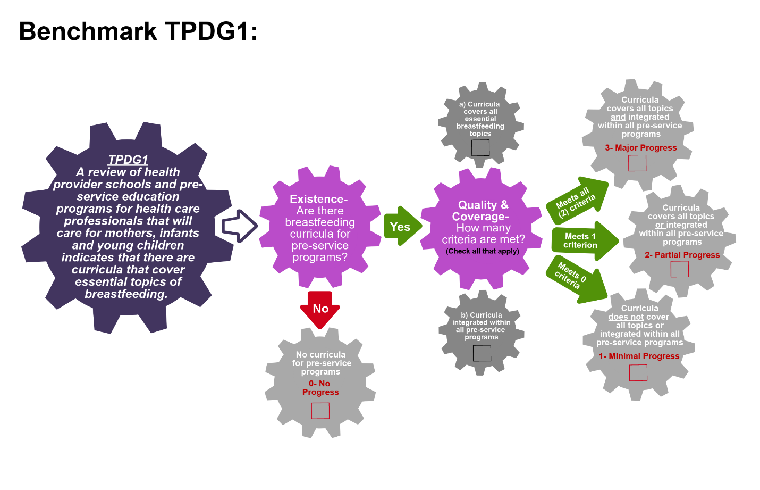
Scoring Pathway
☐
☐
☐
☐
☐
☐

**Insert the final score into the BBFI Calculator**
Instructions: Using the pathway, explain below the evolution of the final agreed score, i.e. rationale for any changes to the score, how the score was calculated (domains and criteria met), gaps identified and address any discrepancies of opinion within the Gear Team or Committee on the final score.
Date | Primary Score | Summary of Discussion | Scoring Justification | Final Score | Gaps identified
Between Meeting1 and 2

Date:
Meeting 2

Date:
Meeting 3

Date:

Data Organization: Please provide as much detail as possible to facilitate accurate scoring of each benchmark and development of recommendations. The relevant Domains are in bold.
TPDG2:Facility-based health care professionals who care for mothers, infants and young children are trained on the essential breastfeeding topics as well as their responsibilities under the Code implementation
Existence:  Brief explanation of BF training | Quality:  Essential BF topics (Annex 4) covered | Effective:  Which in-service programs have breastfeeding curricula integrated? | References/ Data sources

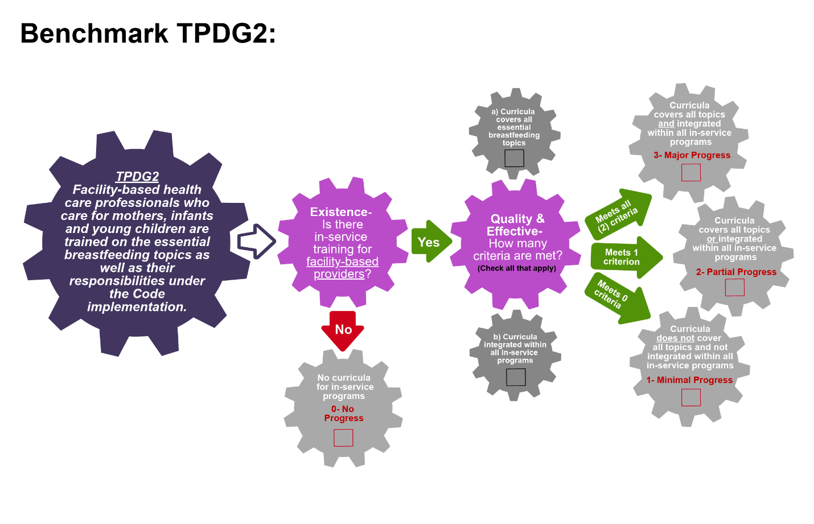
Scoring Pathway

☐
☐
☐
☐
☐
☐

**Insert the final score into the BBFI Calculator**
Instructions: Using the pathway, explain below the evolution of the final agreed score, i.e. rationale for any changes to the score, how the score was calculated (domains and criteria met), gaps identified and address any discrepancies of opinion within the Gear Team or Committee on the final score.
Date | Primary Score | Summary of Discussion | Scoring Justification | Final Score | Gaps identified
Between Meeting1 and 2

Date:
Meeting 2

Date:
Meeting 3

Date:

Data Organization: Please provide as much detail as possible to facilitate accurate scoring of each benchmark and development of recommendations. The relevant Domains are in bold.
TPDG3:Facility-based health care professionals who care for mothers, infants and young children receive hands-on training in essential topics for counseling and support skills for breastfeeding
Existence:  Brief explanation of BF counseling & support skills training | Quality:  Essential BF topics (Annex 5) covered | Effective:  Which in-service programs have breastfeeding curricula integrated? | References/ Data sources

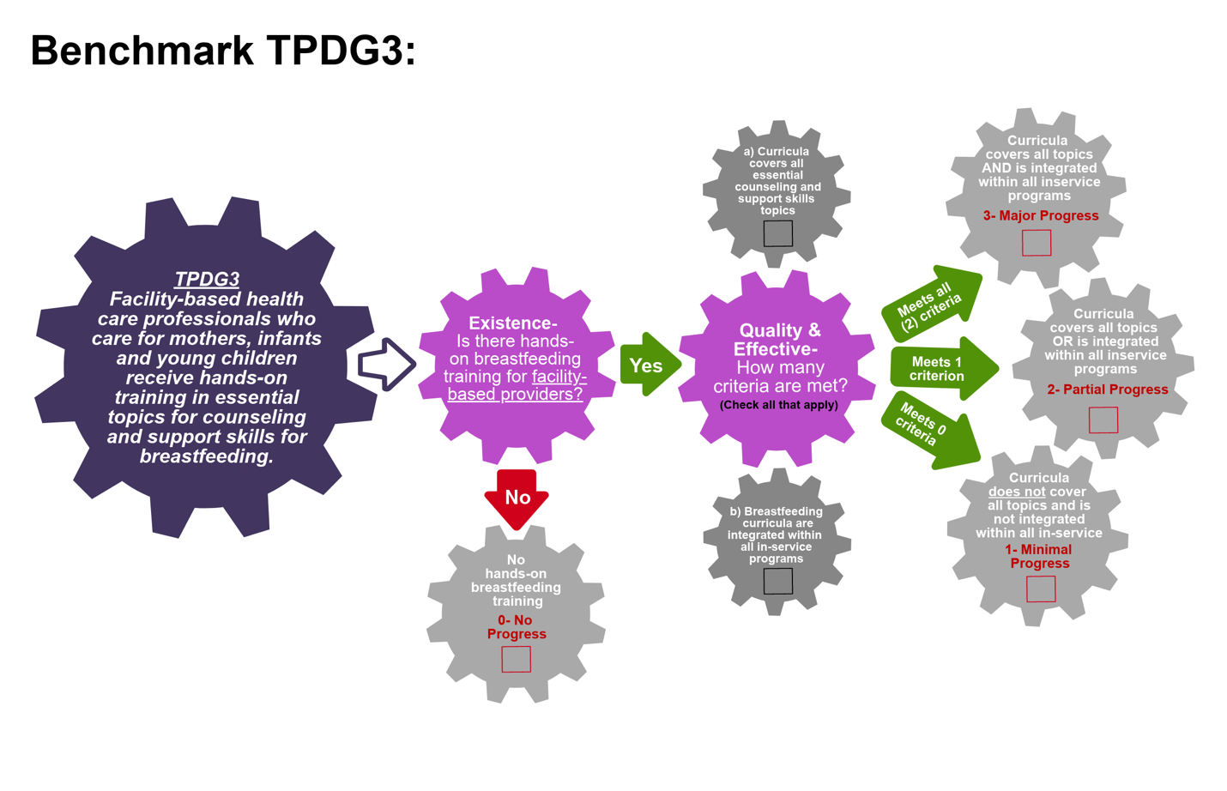
Scoring Pathway

☐

☐

☐
☐
☐
☐

**Insert the final score into the BBFI Calculator**
Instructions: Using the pathway, explain below the evolution of the final agreed score, i.e. rationale for any changes to the score, how the score was calculated (domains and criteria met), gaps identified and address any discrepancies of opinion within the Gear Team or Committee on the final score.
Date | Primary Score | Summary of Discussion | Scoring Justification | Final Score | Gaps identified
Between Meeting1 and 2

Date:
Meeting 2

Date:
Meeting 3

Date:

Data Organization: Please provide as much detail as possible to facilitate accurate scoring of each benchmark and development of recommendations. The relevant Domains are in bold.
TPDG4:Community-based health care professionals who care for mothers, infants and young children are trained on the essential breastfeeding topics as well as their responsibilities under the Code implementation
Existence:  Brief explanation of BF training | Quality:  Essential BF topics (Annex 4) covered | Effective:  Which in-service programs have breastfeeding curricula integrated? | References/ Data sources

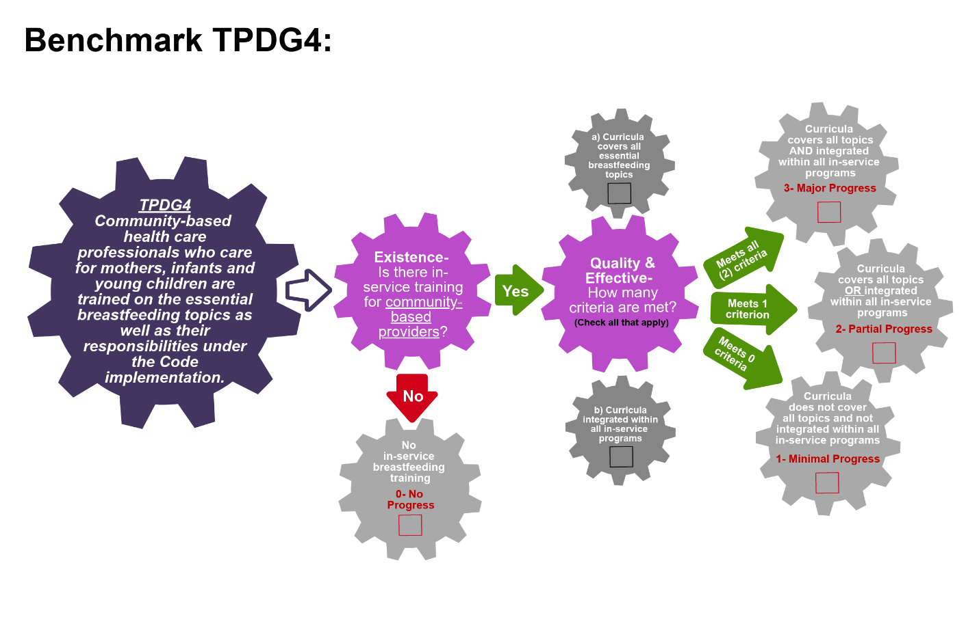
Scoring Pathway
☐
☐
☐
☐
☐
☐

**Insert the final score into the BBFI Calculator**
Instructions: Using the pathway, explain below the evolution of the final agreed score, i.e. rationale for any changes to the score, how the score was calculated (domains and criteria met), gaps identified and address any discrepancies of opinion within the Gear Team or Committee on the final score.
Date | Primary Score | Summary of Discussion | Scoring Justification | Final Score | Gaps identified
Between Meeting1 and 2

Date:
Meeting 2

Date:
Meeting 3

Date:

Data Organization: Please provide as much detail as possible to facilitate accurate scoring of each benchmark and development of recommendations. The relevant Domains are in bold.
TPDG5: Community-based health care professionals who care for mothers, infants and young children receive hands-on training in essential topics for counseling and support skills for breastfeeding
Existence:  Brief explanation of BF counseling & support skills training | Quality:  Essential BF topics (Annex 5) covered | Effective:  Which in-service programs have breastfeeding curricula integrated? | References/ Data sources

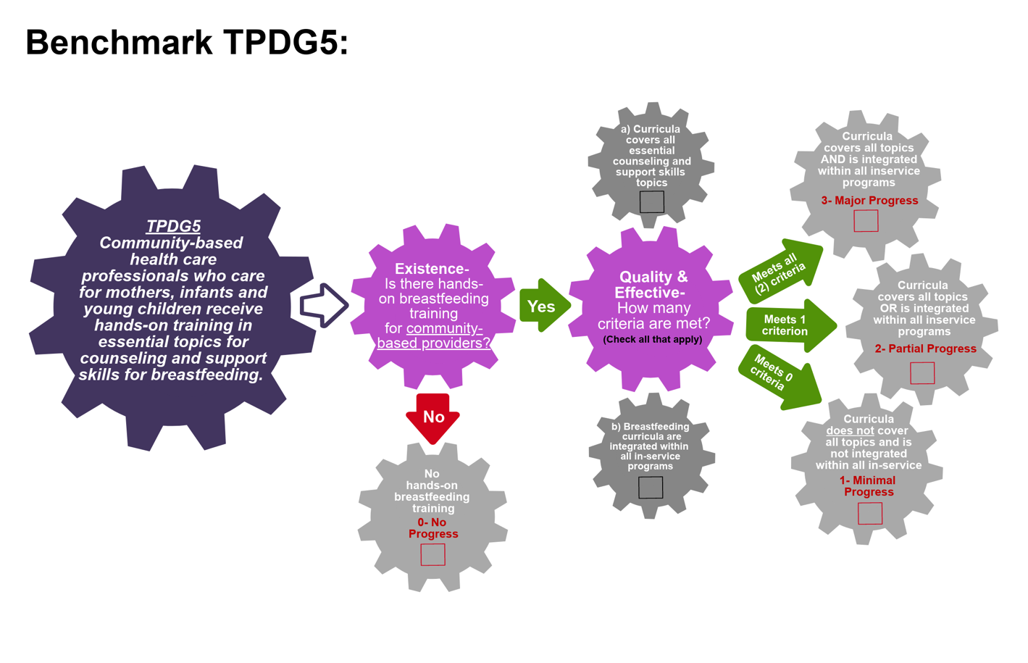
Scoring Pathway

☐
☐
☐
☐
☐
☐

**Insert the final score into the BBFI Calculator*
Instructions: Using the pathway, explain below the evolution of the final agreed score, i.e. rationale for any changes to the score, how the score was calculated (domains and criteria met), gaps identified and address any discrepancies of opinion within the Gear Team or Committee on the final score.
Date | Primary Score | Summary of Discussion | Scoring Justification | Final Score | Gaps identified
Between Meeting1 and 2

Date:
Meeting 2

Date:
Meeting 3

Date:

Data Organization: Please provide as much detail as possible to facilitate accurate scoring of each benchmark and development of recommendations. The relevant Domains are in bold.
TPDG6: CHWs and volunteers that work with mothers, infants, and young children are trained on the essential breastfeeding topics as well as their responsibilities under the Code implementation.
Existence:  Brief explanation of BF training | Quality:  Essential BF topics (Annex 4) covered | Effective:  Which in-service programs have breastfeeding curricula integrated? | References/ Data sources

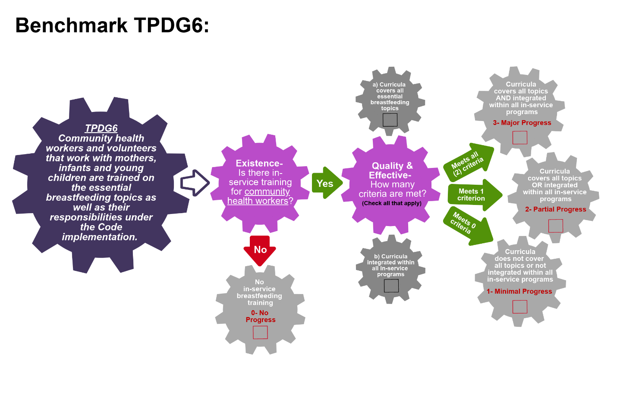
Scoring Pathway
☐

☐
☐
☐

☐

☐

**Insert the final score into the BBFI Calculator**
Instructions: Using the pathway, explain below the evolution of the final agreed score, i.e. rationale for any changes to the score, how the score was calculated (domains and criteria met), gaps identified and address any discrepancies of opinion within the Gear Team or Committee on the final score.
Date | Primary Score | Summary of Discussion | Scoring Justification | Final Score | Gaps identified
Between Meeting1 and 2

Date:
Meeting 2

Date:
Meeting 3

Date:

Data Organization: Please provide as much detail as possible to facilitate accurate scoring of each benchmark and development of recommendations. The relevant Domains are in bold.
TPDG7: CHWs and volunteers that work with mothers, infants, and young children receive hands-on training in essential topics for counseling and support skills for breastfeeding
Existence:  Brief explanation of BF counseling & support skills training | Quality:  Essential BF topics (Annex 5) covered | Effective:  Which in-service programs have breastfeeding curricula integrated? | References/ Data sources

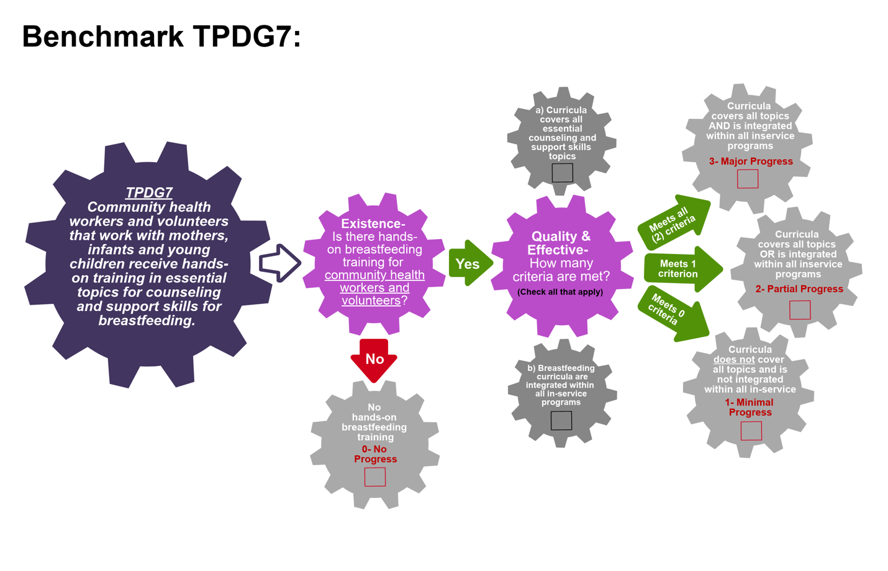
Scoring Pathway

☐
☐
☐
☐
☐
☐

**Insert the final score into the BBFI Calculator**
Instructions: Using the pathway, explain below the evolution of the final agreed score, i.e. rationale for any changes to the score, how the score was calculated (domains and criteria met), gaps identified and address any discrepancies of opinion within the Gear Team or Committee on the final score.
Date | Primary Score | Summary of Discussion | Scoring Justification | Final Score | Gaps identified
Between Meeting1 and 2

Date:
Meeting 2

Date:
Meeting 3

Date:

Data Organization: Please provide as much detail as possible to facilitate accurate scoring of each benchmark and development of recommendations. The relevant Domains are in bold.
TPDG8: There exist national/subnational master trainers in breastfeeding
Existence:  List the facilities where master trainers in BF operate | Coverage:  National, sub-national or local coverage | Coverage:  Certification of master trainers (national/subnational or international) | References/ Data sources

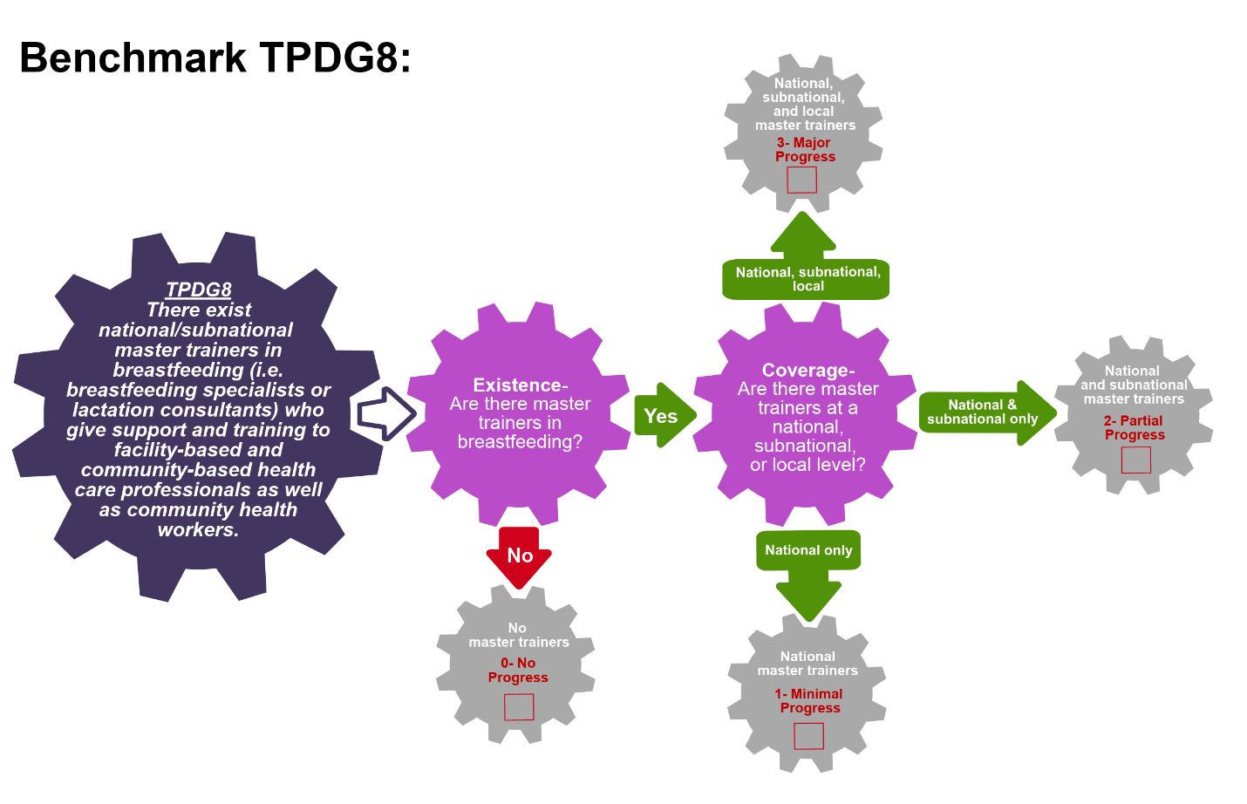
Scoring Pathway

☐
☐
☐
☐

**Insert the final score into the BBFI Calculator**
Instructions: Using the pathway, explain below the evolution of the final agreed score, i.e. rationale for any changes to the score, how the score was calculated (domains and criteria met), gaps identified and address any discrepancies of opinion within the Gear Team or Committee on the final score.
Date | Primary Score | Summary of Discussion | Scoring Justification | Final Score | Gaps identified
Between Meeting1 and 2

Date:
Meeting 2

Date:
Meeting 3

Date:
Data Organization: Please provide as much detail as possible to facilitate accurate scoring of each benchmark and development of recommendations. The relevant Domains are in bold.
TPDG9: Breastfeeding training programs that are delivered by different entities (e.g. face-to-face; on-line learning) through different modalities are coordinated.
Existence:  List the available BF training programs | Coverage:  List the coordinating mechanisms | Coverage:  Describe how these programs are coordinated | References/ Data sources

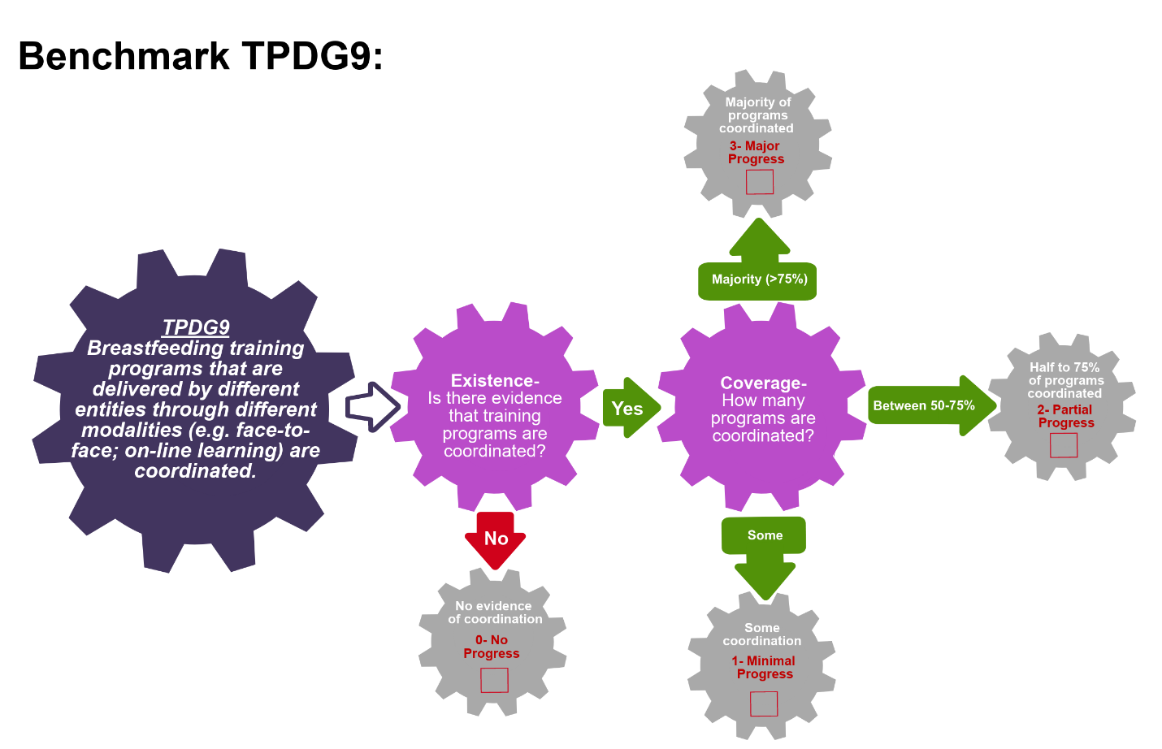
Sc oring Pathway
☐
☐
☐
☐

**Insert the final score into the BBFI Calculator**
Instructions: Using the pathway, explain below the evolution of the final agreed score, i.e. rationale for any changes to the score, how the score was calculated (domains and criteria met), gaps identified and address any discrepancies of opinion within the Gear Team or Committee on the final score.
Date | Primary Score | Summary of Discussion | Scoring Justification | Final Score | Gaps identified
Between Meeting1 and 2

Date:
Meeting 2

Date:
Meeting 3

Date:
Data Organization: Please provide as much detail as possible to facilitate accurate scoring of each benchmark and development of recommendations. The relevant Domains are in bold.
TPDG10: Breastfeeding information and skills are integrated into related training programs (e.g. maternal and child health, IMCI.
Existence:  List the available training programs in maternal/child health | Coverage:  Explain how BF skills and training are integrated | References/ Data sources

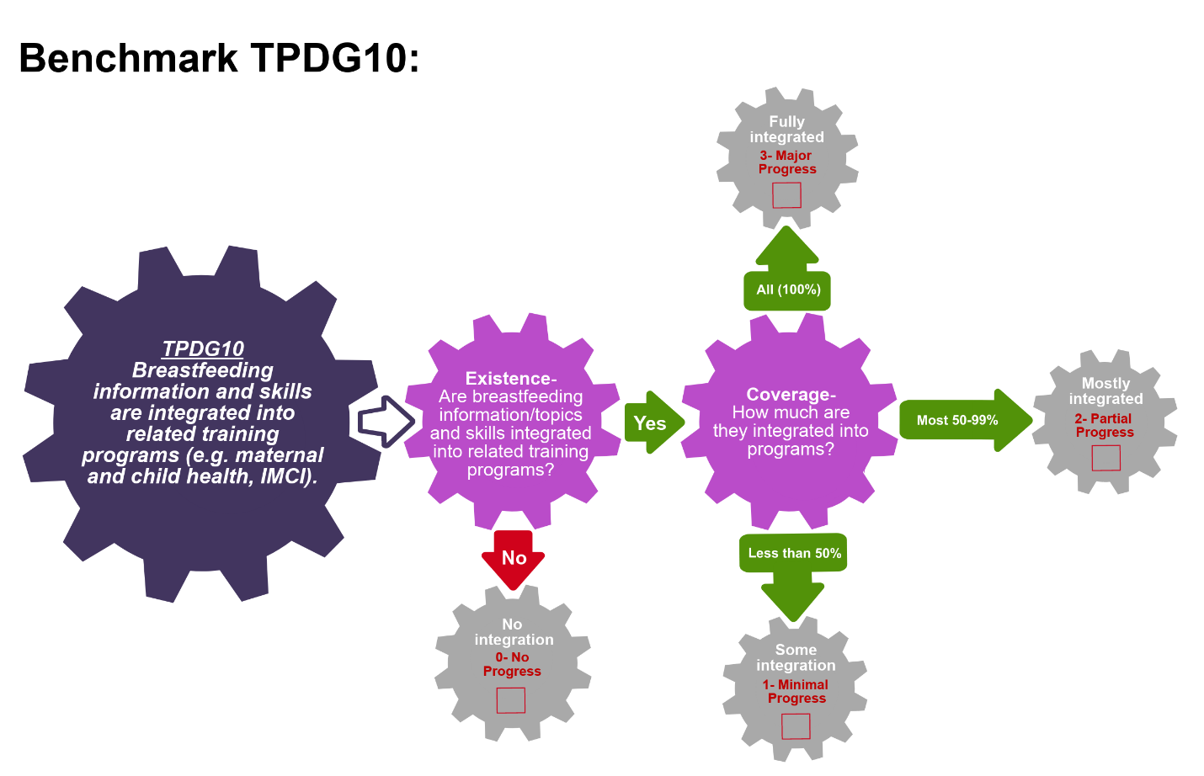
Scoring Pathway
☐

☐
☐
☐

**Insert the final score into the BBFI Calculator**
Instructions: Using the pathway, explain below the evolution of the final agreed score, i.e. rationale for any changes to the score, how the score was calculated (domains and criteria met), gaps identified and address any discrepancies of opinion within the Gear Team or Committee on the final score.
Date | Primary Score | Summary of Discussion | Scoring Justification | Final Score | Gaps identified
Between Meeting1 and 2

Date:
Meeting 2

Date:
Meeting 3

Date:
Data Organization: Please provide as much detail as possible to facilitate accurate scoring of each benchmark and development of recommendations. The relevant Domains are in bold.
TPDG11: National standards and guidelines for breastfeeding promotion and support have been developed and disseminated to all facilities and personnel providing maternity and newborn care.
Existence:  List the available BF standards & guidelines | Coverage:  List any standards and guidelines under development | Coverage:  Describe where they were disseminated | Coverage:  What % of facilities does this represent? | References/ Data sources

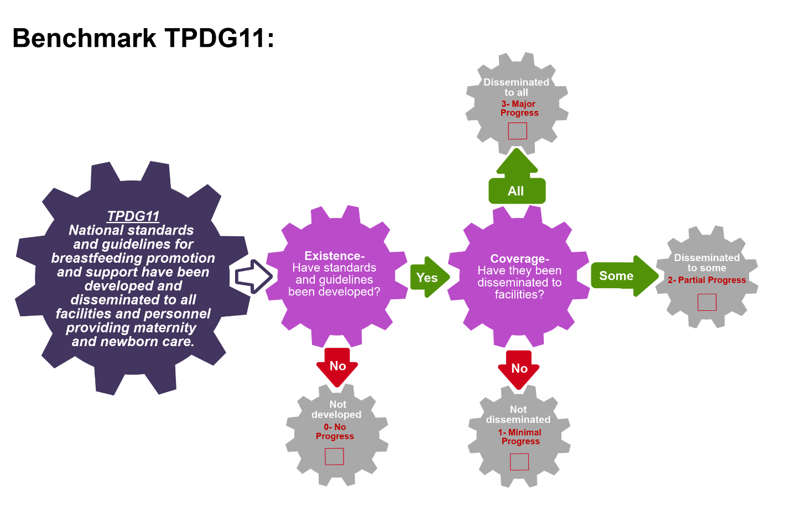
Scoring Pathway

☐
☐
☐
☐

**Insert the final score into the BBFI Calculator**
Instructions: Using the pathway, explain below the evolution of the final agreed score, i.e. rationale for any changes to the score, how the score was calculated (domains and criteria met), gaps identified and address any discrepancies of opinion within the Gear Team or Committee on the final score.
Date | Primary Score | Summary of Discussion | Scoring Justification | Final Score | Gaps identified
Between Meeting1 and 2

Date:
Meeting 2

Date:
Meeting 3

Date:

Data Organization: Please provide as much detail as possible to facilitate accurate scoring of each benchmark and development of recommendations. The relevant Domains are in bold.
TPDG12: Assessment systems are in place for designating BFHI/Ten Steps facilities.
Existence:  Describe the BFHI assessment system | Quality:  List the BFHI UNICEF/WHO global criteria included in the assessment system | Effective:  Describe the inclusion of BFHI certification in the National Breastfeeding Plan | References/ Data sources

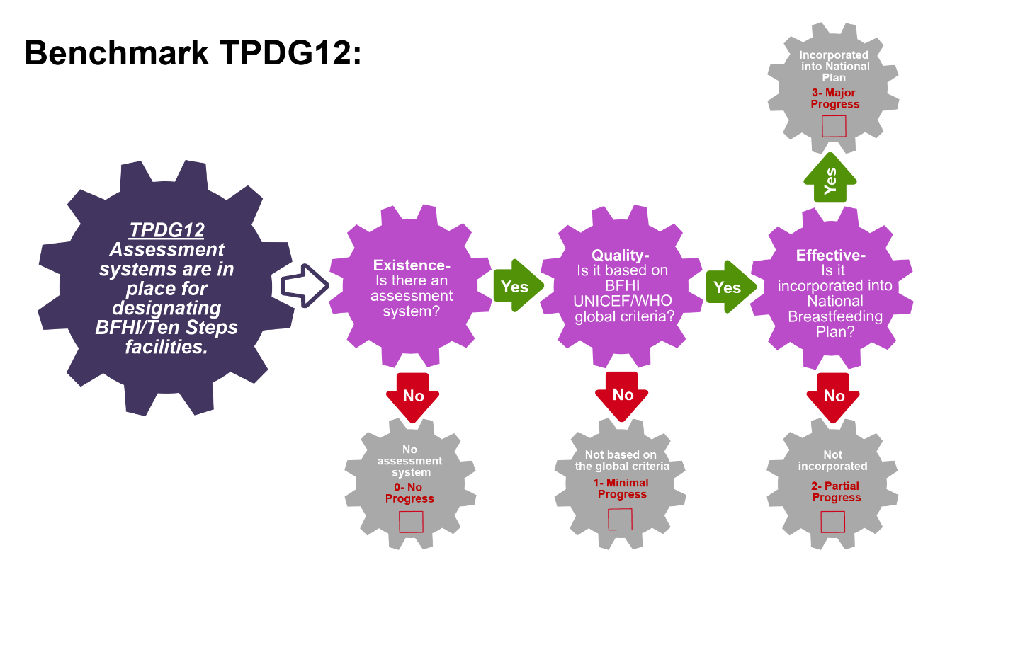
Scoring Pathway

☐

☐
☐
☐

**Insert the final score into the BBFI Calculator**
Instructions: Using the pathway, explain below the evolution of the final agreed score, i.e. rationale for any changes to the score, how the score was calculated (domains and criteria met), gaps identified and address any discrepancies of opinion within the Gear Team or Committee on the final score.
Date | Primary Score | Summary of Discussion | Scoring Justification | Final Score | Gaps identified
Between Meeting1 and 2

Date:
Meeting 2

Date:
Meeting 3

Date:

Data Organization: Please provide as much detail as possible to facilitate accurate scoring of each benchmark and development of recommendations. The relevant Domains are in bold.
TPDG13: Reassessment systems are in place to reevaluate designated Baby-Friendly/Ten Steps hospitals or maternity services to determine if they continue to adhere to the Baby Friendly/Ten Steps criteria.
Existence:  Describe the BFHI reassessment system | Quality:  List the timeframe/schedule for reassessment | Quality:  Describe the inclusion of the reassessment system in the National Breastfeeding Plan | References/ Data sources

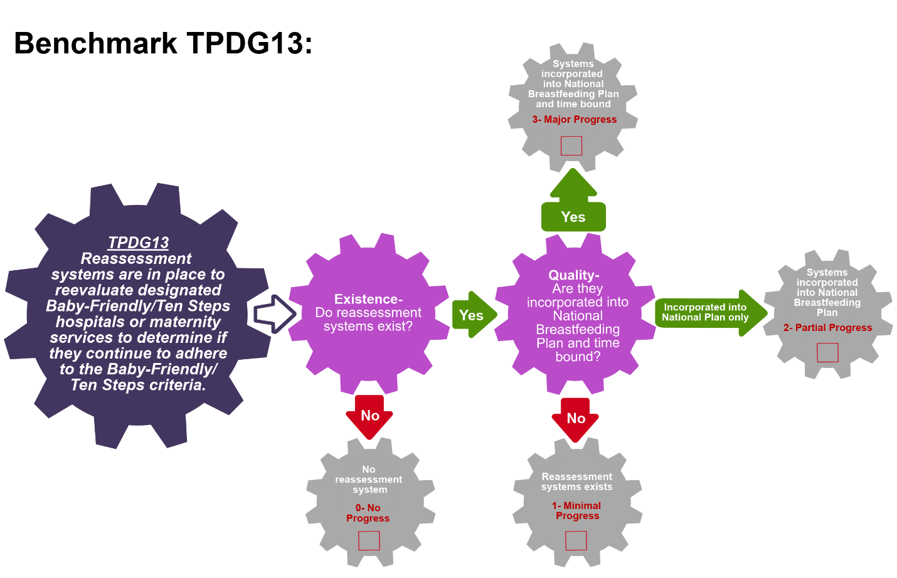
Scoring Pathway
☐

☐
☐
☐

**Insert the final score into the BBFI Calculator**
Instructions: Using the pathway, explain below the evolution of the final agreed score, i.e. rationale for any changes to the score, how the score was calculated (domains and criteria met), gaps identified and address any discrepancies of opinion within the Gear Team or Committee on the final score.
Date | Primary Score | Summary of Discussion | Scoring Justification | Final Score | Gaps identified
Between Meeting1 and 2

Date:
Meeting 2

Date:
Meeting 3

Date:

Data Organization: Please provide as much detail as possible to facilitate accurate scoring of each benchmark and development of recommendations. The relevant Domains are in bold.
TPDG14: More than 66.6% of deliveries take place in hospitals and clinics designated or reassessed as “Baby- Friendly” in the last 5 years.
Coverage:  Describe the BFHI certification system | Coverage:  Number/Percentage of BFHI facilities (public and private) | Coverage:  Percentage of deliveries in the BFHI facilities (public and private) | References/ Data sources

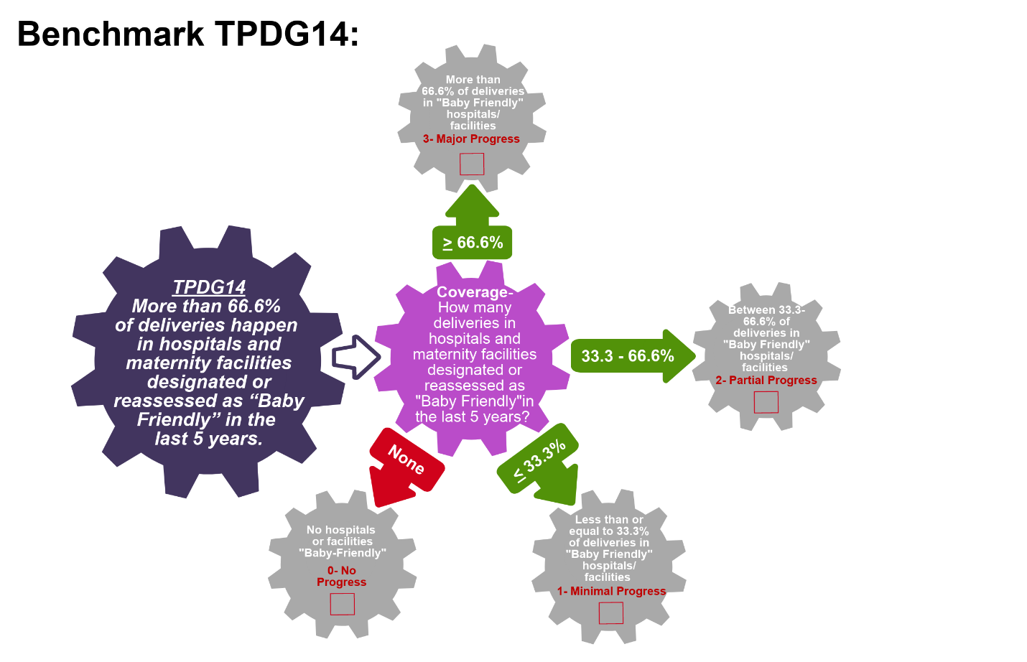
Scoring Pathway
☐

☐
☐
☐

**Insert the final score into the BBFI Calculator**
Instructions: Using the pathway, explain below the evolution of the final agreed score, i.e. rationale for any changes to the score, how the score was calculated (domains and criteria met), gaps identified and address any discrepancies of opinion within the Gear Team or Committee on the final score.
Date | Primary Score | Summary of Discussion | Scoring Justification | Final Score | Gaps identified
Between Meeting1 and 2

Date:
Meeting 2

Date:
Meeting 3

Date:

Data Organization: Please provide as much detail as possible to facilitate accurate scoring of each benchmark and development of recommendations. The relevant Domains are in bold.
TPDG15: Health facility-based community outreach and support activities related to breastfeeding are being implemented
Existence:  Describe the facility-based activities | Existence:  Responsible body/ organization | Quality:  List the areas these activities cover (i.e. local, state, regional or national) | Effective:  Describe links to community-based activities and quality of implementation | References/ Data sources

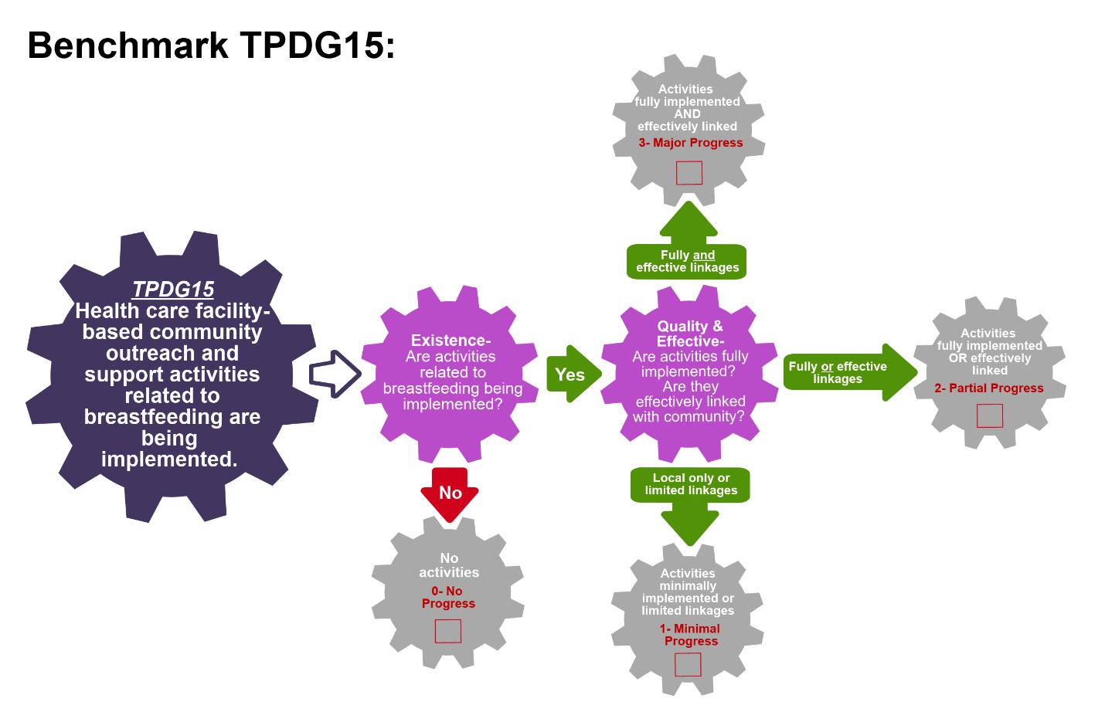
Scoring Pathway

☐
☐
☐

☐

**Insert the final score into the BBFI Calculator**
Instructions: Using the pathway, explain below the evolution of the final agreed score, i.e. rationale for any changes to the score, how the score was calculated (domains and criteria met), gaps identified and address any discrepancies of opinion within the Gear Team or Committee on the final score.
Date | Primary Score | Summary of Discussion | Scoring Justification | Final Score | Gaps identified
Between Meeting1 and 2

Date:
Meeting 2

Date:
Meeting 3

Date:

Data Organization: Please provide as much detail as possible to facilitate accurate scoring of each benchmark and development of recommendations. The relevant Domains are in bold.
TPDG16: Community-based breastfeeding outreach and support activities have national coverage
Existence:  Describe the community-based activities | Existence:  Responsible body/ organization | Coverage:  List the areas these activities cover (i.e. local, state, regional or national) | Coverage:  List the areas the target populations for these activities | References/ Data sources

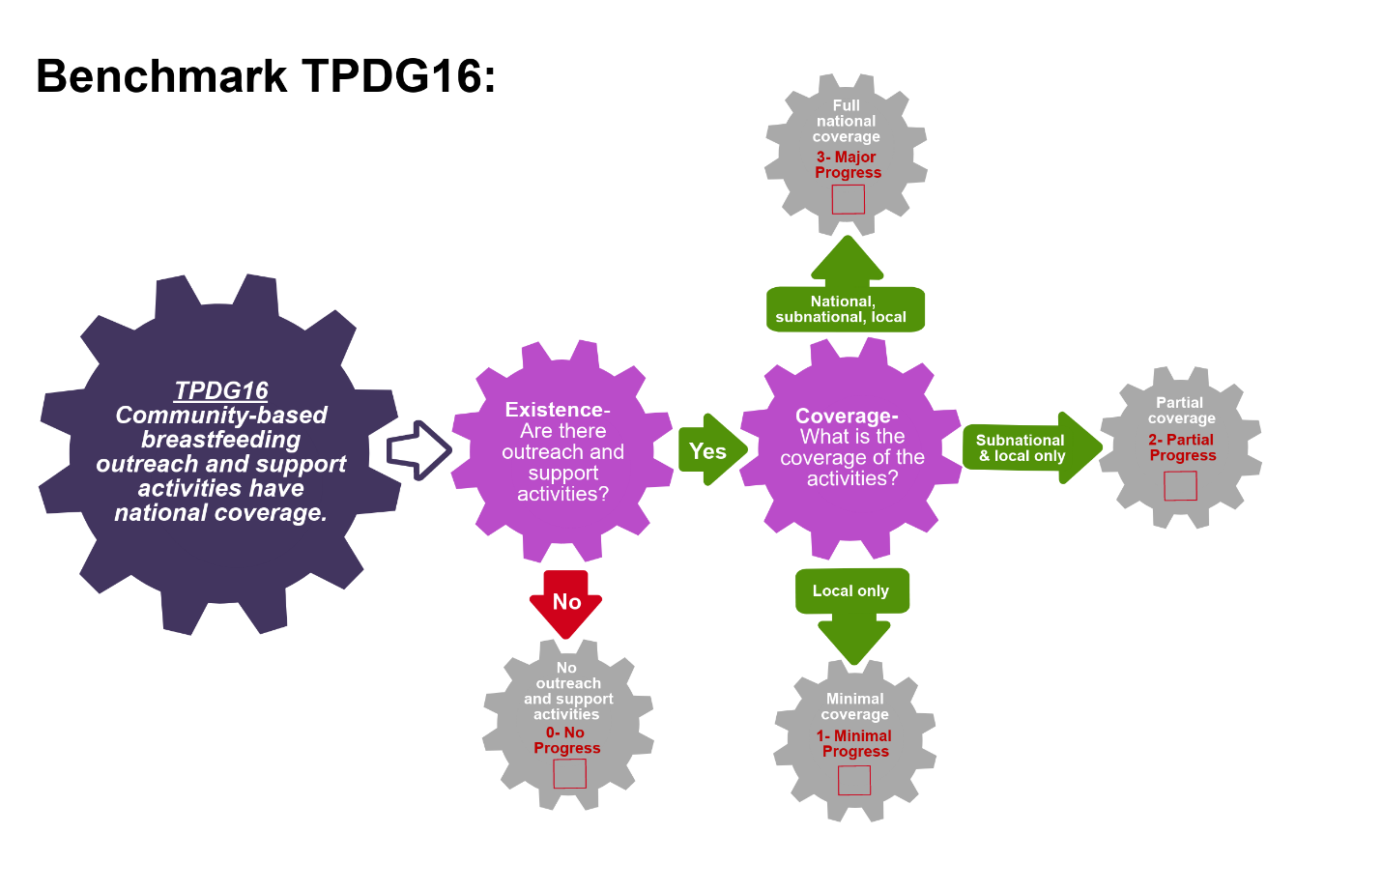
Scoring Pathway

☐

☐
☐
☐

**Insert the final score into the BBFI Calculator**
Instructions: Using the pathway, explain below the evolution of the final agreed score, i.e. rationale for any changes to the score, how the score was calculated (domains and criteria met), gaps identified and address any discrepancies of opinion within the Gear Team or Committee on the final score.
Date | Primary Score | Summary of Discussion | Scoring Justification | Final Score | Gaps identified
Between Meeting1 and 2

Date:
Meeting 2

Date:
Meeting 3

Date:
Data Organization: Please provide as much detail as possible to facilitate accurate scoring of each benchmark and development of recommendations. The relevant Domains are in bold.
TPDG17: There are trained and certified lactation management specialists available to provide supportive supervision for breastfeeding program delivery.
Existence:  Describe the system for deploying lactation management specialists | Existence:  Responsible body/organization | Coverage:  List the areas covered (i.e. local, state, regional or national) | References/ Data sources

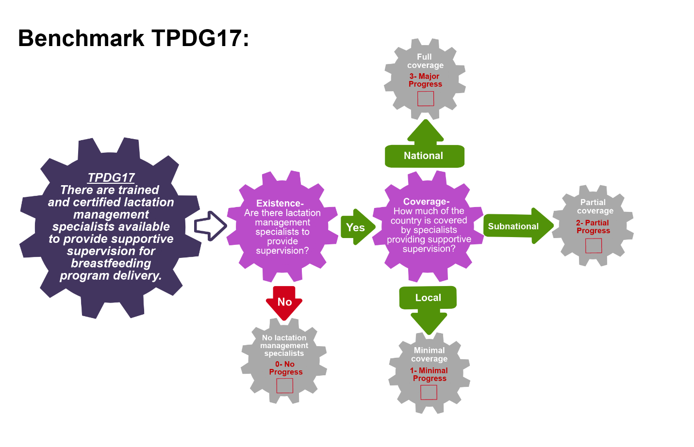
Scoring Pathway
☐

☐
☐
☐

**Insert the final score into the BBFI Calculator**
Instructions: Using the pathway, explain below the evolution of the final agreed score, i.e. rationale for any changes to the score, how the score was calculated (domains and criteria met), gaps identified and address any discrepancies of opinion within the Gear Team or Committee on the final score.
Date | Primary Score | Summary of Discussion | Scoring Justification | Final Score | Gaps identified
Between Meeting1 and 2

Date:
Meeting 2

Date:
Meeting 3

Date:
Recommended Actions
Training and Program Delivery Gear (TPDG)

This template can be used to summarize possible recommendations for improvement where benchmarks have scored No Progress (0), Minimal Progress (1) or Partial Progress (2). This summary will form the basis of each Gear Team’s presentation during Meeting 4. Guidance will be made available on developing recommendations and prioritizing them.
Gaps Identified | Recommended Actions

Adapted from WBTi (2014).
Adapted from WBTi (2014).
Adapted from WBTi (2014).
Adapted from WBTi (2014).
Adapted from WBTi (2014).
Adapted from WBTi (2014).
Adapted from WBTi (2014).
i.e. breastfeeding specialists or lactation consultants who give support and training to facility-based and community-based health care professionals and community health workers.
Adapted from WBTI (2014).
Adapted from WBTi (2014).
Adapted from WBTi (2014).
Adapted from WHO’s Infant and Young Child Feeding assessment tool (2003).
Adapted from WHO’s Infant and Young Child Feeding assessment tool (2003).

